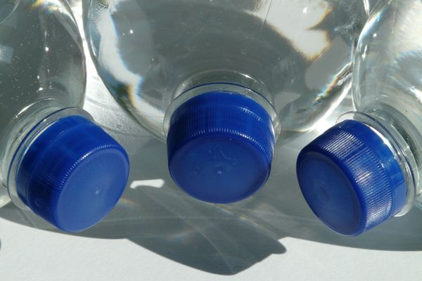
Tool Box Talk - Importance of Hydration

We've all experienced it at some point when working or playing hard – fatigue sets in, your mouth feels dry and your legs are heavy and maybe you even get a headache. These are all common signs of dehydration.

When you are working hard, body fluid is lost through sweat. If the fluid lost through sweat is not replaced, dehydration and early fatigue are unavoidable. Losing even 2% of body fluids (less than 3.5 pounds in a 180-pound person) can impair performance by increasing fatigue and affecting cognitive skills. During the summer heat it's easy for to become dehydrated if you don't drink enough fluids to replace what is lost in sweat.
However, dehydration can easily be prevented
- When to drink: Ensure you drink before you start working, trying to catch-up for lost fluids after a period of time is very difficult. Also, drink before you get thirsty. By the time you're thirsty you are already dehydrated, so it's important to drink at regular intervals – especially when it is hot outside.
- What to drink: Water is truly one of the best things to drink. Research also shows that a lightly flavored beverage with a small amount of sodium encourages people to drink enough to stay hydrated. The combination of flavor and electrolytes in a sports drink like Gatorade provides one of the best choices to help you stay properly hydrated.
- What not to drink: During activity, avoid drinks with high sugar content such as soda and even fruit juices. These are slow to absorb into the body. Also alcohol and caffeinated beverages should be avoided.
Many people ask how much to drink and that truly depends on your activity level and how much your body is losing fluids. In general, when you are working and sweating, you should drink at least every half-hour. Ensure you are drinking enough to replace your lost fluids. A good rule of thumb from a wise man says: “if you aren’t urinating, you’re not drinking enough”.
This toolbox topic was reviewed by ______________________________________ on ___________________________ with the following employees:

