Tool Box Talk - National Weather Service Alerts
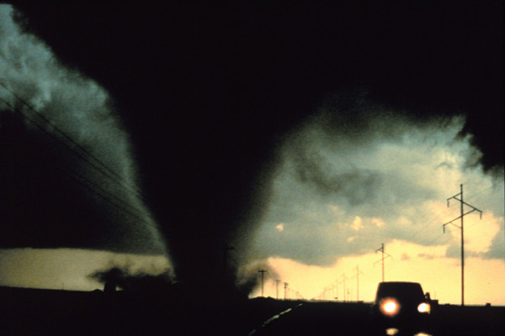

Spring is here and we’re getting into the Tornado season for this area. It’s important to review what the various National Weather Service alerts mean.
A Severe Thunderstorm Watch
That means that conditions are favorable for a severe thunderstorm in the area(s) covered under the watch. A Severe Thunderstorm Warning That means that a severe thunderstorm has been spotted in the area either visually or via Doppler Radar. This could mean high winds, lightning and heavy rain.
A Tornado Watch
That means the conditions are favorable for a tornado in the area(s) covered under the Tornado Watch. You do not need to take cover, but you should keep an eye on the conditions and stay near a radio/tv/weather radio.
A Tornado Warning
That means that a tornado has been spotted in the area covered either visually by someone on the ground or via Doppler Radar. That means take cover immediately.
If you have a basement or a storm shelter in your home that is a good place to go. If you're not sure where to go or what help in determining the best place, checkout the FEMA website at www.fema.gov for detailed information on how to determine the safest place to be.
This toolbox topic was reviewed by ______________________________________ on ___________________________ with the following employees:

