Tool Box Talk - Your Back IQ Test (Part 2)
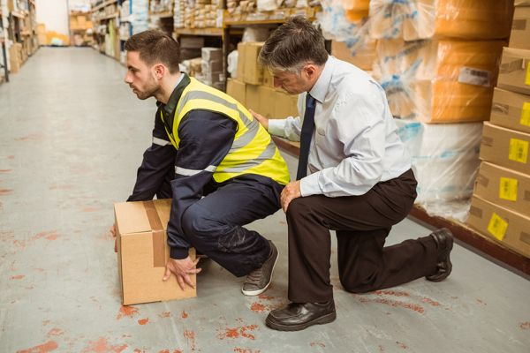
Lifting safely is one the most important things you can do to protect your back throughout your lifetime. Yesterday we started taking the Back IQ Test. Let’s finish the quiz.

Q: Which muscles are most important for keeping the spine in its strong S-shaped curve? (Wait for some answers)
A: Abdominal muscles, which work in cooperation with back muscles to support your spine. The trouble is, abdominals tend to weaken over time. It helps to tighten them during a heavy lift, but more importantly, keep them in good shape.
Q: How can stress in your life effect back pain? (Wait for some answers)
A: Whether you're aware of it or not, emotional stress can tighten muscles. Often, fatigued back muscles are the most effected and the first to feel it. It's been said that back ache is just a tension headache that "slipped."
Q: What time of the day are back strains most likely to happen? (Wait for some answers)
A: In the morning, or at the beginning of a work shift, when muscles aren't "warmed up." Trends also show an increase following the lunch hour, perhaps because blood circulation is in the stomach, instead of the large muscles, and because people may be sleepy and inattentive then.
Q: How does keeping flexible help prevent back and muscle strains? (Wait for some answers)
A: Muscles tend to shorten when not used to their full capacity. Flexible muscles are less likely to be strained and injured than "tight" muscles, when sudden or heavy power is required. Pre-work stretching programs like we do have been very successful in preventing back and muscle strains through many industries. Take a tip from professional athletes--they warm up before a game! Even five minutes helps!
This toolbox topic was reviewed by ______________________________________ on ___________________________ with the following employees:

