What is a Confined Space?
Confined spaces have limited openings for entry and exit, such as silos, vats, ship holds, sewers, tunnels, large pipelines, and other such spaces that workers could enter to perform work.
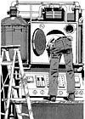 | 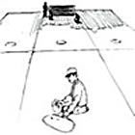
The OHS Regulation defines a confined space as follows:
"confined space", except as otherwise determined by the Board, means an area, other than an underground working, that
(a) is enclosed or partially enclosed,
(b) is not designed or intended for continuous human occupancy,
(c) has limited or restricted means for entry or exit that may complicate the provision of first aid, evacuation, rescue or other emergency response service, and
(d) is large enough and so configured that a worker could enter to perform assigned work;

Types of confined space:

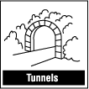
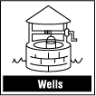
Confined spaces can be below or above ground. Confined spaces can be found in almost any workplace. A confined space, despite its name, is not necessarily small. Examples of confined spaces include silos, vats, hoppers, utility vaults, tanks, sewers, pipes, access shafts, truck or rail tank cars, aircraft wings, boilers, manholes, manure pits and storage bins. Ditches and trenches may also be a confined space when access or egress is limited.
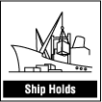
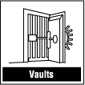
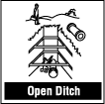

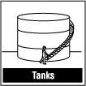
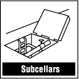
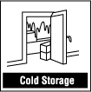
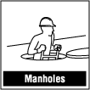

What are the hazards in a confined space?
All hazards found in a regular workspace can also be found in a confined space. However, they can be even more hazardous in a confined space than in a regular worksite.
Hazards in confined spaces can include:
- Poor air quality: There may be an insufficient amount of oxygen for the worker to breathe. The atmosphere might contain a poisonous substance that could make the worker ill or even cause the worker to lose consciousness. Natural ventilation alone will often not be sufficient to maintain breathable quality air.
- Chemical exposures due to skin contact or ingestion as well as inhalation of 'bad' air.
- Fire Hazard: There may be an explosive/flammable atmosphere due to flammable liquids and gases and combustible dusts which if ignited would lead to fire or explosion.
- Process-related hazards such as residual chemicals, release of contents of a supply line.
- Noise.
- Safety hazards such as moving parts of equipment, structural hazards, entanglement, slips, falls.
- Radiation.
- Temperature extremes including atmospheric and surface.
- Shifting or collapse of bulk material.
- Barrier failure resulting in a flood or release of free-flowing solid.
- Uncontrolled energy including electrical shock.
- Visibility.
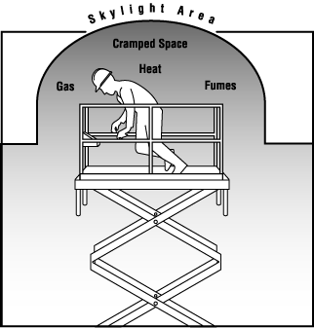
- Biological hazards.

Why is working in a confined space more hazardous than working in other workspaces?
Many factors need to be evaluated when looking for hazards in a confined space. There is smaller margin for error. An error in identifying or evaluating potential hazards can have more serious consequences. In some cases, the conditions in a confined space are always extremely hazardous. In other cases, conditions are life threatening under an unusual combination of circumstances. This variability and unpredictability is why the hazard assessment is extremely important and must be taken very seriously each and every time one is done.
Some examples include:
- The entrance/exit of the confined space might not allow the worker to get out in time should there be a flood or collapse of free-flowing solid.
- Self-rescue by the worker is more difficult.
- Rescue of the victim is more difficult. The interior configuration of the confined space often does not allow easy movement of people or equipment within it.
- Natural ventilation alone will often not be sufficient to maintain breathable quality air. The interior configuration of the confined space does not allow easy movement of air within it.
- Conditions can change very quickly.
- The space outside the confined space can impact on the conditions inside the confined space and vice versa.
- Work activities may introduce hazards not present initially.

What should be done when preparing to enter the confined space?
The important thing to remember is that each time a worker plans to enter any work space, the worker should determine if that work space is considered a confined space. Be sure the confined space hazard assessment and control program has been followed.
The next question to ask is - Is it absolutely necessary that the work be carried out inside the confined space? In many cases where there have been deaths in confined spaces, the work could have been done outside the confined space!
Before entering any confined space, a trained and experienced person should identify and evaluate all the existing and potential hazards within the confined space. Evaluate activities both inside and outside the confined space.
Air quality testing: The air within the confined space should be tested from outside of the confined space before entry into the confined space. Care should be taken to ensure that air is tested throughout the confined space - side-to-side and top to bottom. A trained worker using detection equipment which has remote probes and sampling lines should do the air quality testing. Always ensure the testing equipment is properly calibrated and maintained. The sampling should show that:
- The oxygen content is within safe limits - not too little and not too much.
- A hazardous atmosphere (toxic gases, flammable atmosphere) is not present.
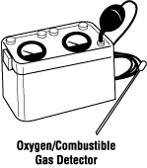
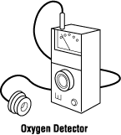
- Ventilation equipment is operating properly.

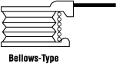
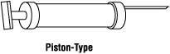

The results of the tests for these hazards are to be recorded on the Entry Permit along with the equipment or method(s) that were used in performing the tests.
Air testing may need to be ongoing depending on the nature of the potential hazards and the nature of the work. Conditions can change while workers are inside the confined space and sometimes a hazardous atmosphere is created by the work activities in the confined space.

How are hazards controlled in confined spaces?
The traditional hazard control methods found in regular worksites can be effective in a confined space. These include engineering controls, administrative controls and personal protective equipment. Engineering controls are designed to remove the hazard while administrative controls and personal protective equipment try to minimize the contact with the hazard.
However, often because of the nature of the confined space and depending on the hazard, special precautions not normally required in a regular worksite may also need to be taken. The engineering control commonly used in confined spaces is mechanical ventilation. The Entry Permit system is an example of an administrative control used in confined spaces. Personal protective equipment (respirators, gloves, ear plugs) is commonly used in confined spaces as well.

How is air quality maintained?
Natural ventilation (natural air currents) is usually not reliable and not sufficient to maintain the air quality. Mechanical ventilation (blowers, fans) is usually necessary to maintain air quality.
- If mechanical ventilation is provided, there should be a warning system in place to immediately notify the worker in the event of a hazard or a failure in the ventilation equipment.
- Care should be taken to make sure the air being provided by the ventilation system to the confined space is 'clean' throughout the entire space.
- Ease of air movement throughout the confined space should be considered because of the danger of pockets of toxic gases still remaining even with the use of mechanical ventilation.
- Do not substitute oxygen for fresh air. Increasing the oxygen content will significantly increase the risk of fire and explosion.
- The use of mechanical ventilation should be noted on the entry permit
- Ensure air being removed from the confined space is exhausted away from workers on the outside.

How are fire and explosion prevented?
Work where a flame is used or a source of ignition may be produced (hot work) should not normally be performed in a confined space unless:
- All flammable gases, liquids and vapors are removed before the start of any hot work. Mechanical ventilation is usually used to
  - Keep the concentration of any explosive or flammable hazardous substance less than 10% of its Lower Explosive Limit AND
  - Make sure that the oxygen content in the confined space is not enriched. Oxygen content should be less than 23% but maintained at levels greater than 18%. (These numbers can vary slightly from jurisdiction to jurisdiction.)
- Surfaces coated with combustible material should be cleaned or shielded to prevent ignition.
- Do not bring fuel or fuel containers into the confined space (e.g., gasoline, propane), if possible. Ensure welding equipment is in good condition.
- Where appropriate, use spark resistant tools, and make sure all equipment is bonded or grounded properly.

While doing the hot work, the concentrations of oxygen and combustible materials must be monitored to make certain that the oxygen levels remain in the proper range and the levels of the combustible materials do not get higher than 10% of the Lower Explosive Limit. In special cases it may not be possible, and additional precautions must be taken to ensure the safety of the worker prior to entering the confined space.
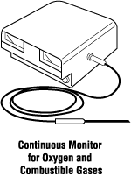

If potential flammable atmosphere hazards are identified during the initial testing, the confined space should be cleaned or purged, ventilated and then tested again before entry to the confined space is allowed. Only after the air testing is within allowable limits should entry occur as the gases used for purging can be extremely hazardous.

How are energy sources controlled?
All potentially hazardous energy sources such as electrical, mechanical, hydraulic, pneumatic, chemical, or thermal must be de-energized and locked out prior to entry to the confined space so that equipment cannot be turned on accidentally.

What are other safety precautions?
Many other situations or hazards may be present in a confined space. Be sure that all hazards are controlled including:
- Any liquids or free-flowing solids are removed from the confined space to eliminate the risk of drowning or suffocation.
- All pipes should be physically disconnected or isolation blanks bolted in place. Closing valves is not sufficient.
- A barrier is present to prevent any liquids or free-flowing solids from entering the confined space.
- The opening for entry into and exit from the confined space must be large enough to allow the passage of a person using protective equipment.

What should happen when work is being done in a confined space?
There should be warning signs to prevent unauthorized entry to the confined space.
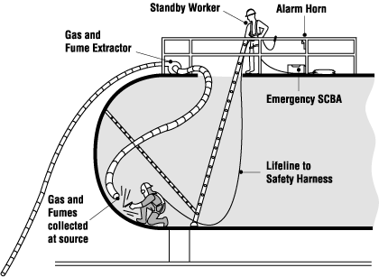

Anyone working in a confined space must be constantly alert for any changing conditions within the confined space. In the event of an alarm from monitoring equipment or any other indication of danger, workers should immediately leave the confined space.
Another worker, the attendant (also known’s as the Safety Watch or Standby), is posted outside the confined space and continuously monitors the workers inside the confined space. The Safety Watch has the following duties:
- Understands the nature of the hazards that may be found inside the particular confined space and can recognize signs, symptoms and behavioral effects that workers in the confined space could experience.
- Monitors the confined space and surrounding area and is on the lookout for dangerous conditions.
- Remains outside the confined space and does no other work which may interfere with their primary duty of monitoring the workers inside the confined space.
- Maintains constant two-way communication with the workers in the confined space.
- Orders the immediate evacuation if a potential hazard, not already controlled for, is detected.
- Calls for emergency assistance immediately if an emergency develops.
- Is immediately available to provide non-entry emergency assistance when needed.
- Can provide entry rescue only after the most stringent precautions are taken and another Safety Watch is immediately available
Should a worker leave a confined space for a short time (for example, coffee break, getting additional material for their work.), the confined space should be re-tested before the worker re-enters. If the confined space has been continuously monitored by equipment that can show the details of the atmosphere during the time absent from the confined space and this information can be seen from outside the confined space, it can be re-entered without retesting. If there is not continuous air monitoring then the hazard assessment needs to be repeated.
No confined space should be closed off until it has been verified that no person is inside it.
After exiting the confined space, the time of exit should be noted on the entry permit.

What are some emergency response precautions?
If a situation arises where there is a hazardous condition and the worker does not leave or is unable to leave the confined space, rescue procedures should be begin immediately.
The Safety Watch is qualified in confined spaces rescue procedures and will be available immediately outside the confined space to provide emergency assistance if needed. The Safety Watch should be familiar with the structural design of the confined space. The Safety Watch is in constant communication with the worker inside the confined space and will:
- Have an alarm for calling for help.
- Have all required rescue equipment (for example, safety harnesses, lifting equipment, a lifeline) immediately available and be trained in its use.
- Hold a basic first aid certificate.
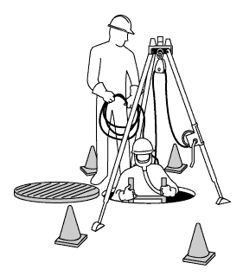
- Can do Cardiopulmonary Resuscitation (CPR).

The detailed plan for emergency response to an injury or other emergency within the confined space should be described in detail in the Confined Space Hazard Assessment and Control Program.
Rescue the victims from outside of the confined space, if possible. No other worker should enter a confined space to attempt a rescue unless that worker is fully trained in the rescue procedures and is wearing the appropriate personal protective equipment. More than 60% of deaths in confined spaces are would-be rescuers, who are not fully trained and adequately equipped.
Another worker qualified in confined spaces rescue procedures must be present outside the confined space before the first rescuer enters the confined space. Do not use the same air as the confined space workers you are rescuing. Wear SCBA (self contained breathing apparatus) or supplied air respirator with an escape bottle.

Is worker training important?
Yes, appropriate training is extremely important to working safely in confined spaces. Hands-on training should be an essential part of the confined space training.
Every worker that enters a confined space must be fully trained on the following:
- Recognition and identification of potential hazards associated with the confined spaces that will be entered.
- Evaluation and control procedures for the identified or potential hazards.
- Set-up, use and limitations of all equipment such as emergency equipment, ventilation equipment (blowers), hazardous energy control, isolation and lockout equipment, and air quality monitors (e.g., Oxygen/combustible meters) that will be used while in the confined space.
- Set-up, use and limitations of all personal protective equipment (e.g., full-body harness, respirators) that the worker will be using while in the confined space.
- All safe work procedures for entering the confined space as outlined in the employer's Confined Space Hazard Assessment Program.
- Procedures to follow in the event of a situation developing that could present additional risk to the worker or an emergency.
- The specific work to be done while in the confined space.
- To work in a manner that will not endanger lives.
Workers with emergency rescue responsibilities will need additional specialized training. All confined space training should include some hands-on training with the safety equipment including the personal protective equipment and safety harnesses. Rescue procedures should be practiced frequently so there is a high level of proficiency. Employers should keep records of all confined spaces training including refresher courses.

