Health, Safety and Environment

Lessons Learned
Severed Thumb
Subject | Woodworking Equipment Thumb Injury
Situation | 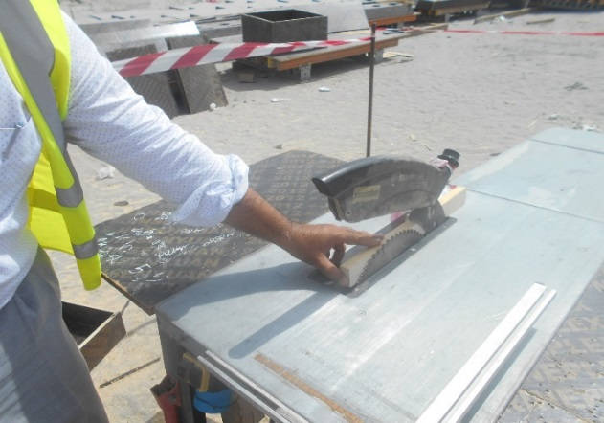  During preparations for formwork, a contractor employee needed to trim a piece of wood. Without consideration to the use of the correct equipment, the employee decided to use a bench saw. Furthermore, the employee chose to operate the equipment, despite four trained and authorised bench saw operators being available.  While trimming the piece of wood, his left hand came into contact with the cutting blade, severing his thumb. The workers severed thumb could not be reattached.  Supervision was available but, did not prevent the unauthorised use of the bench saw.
Lessons Learned | The use of dangerous machinery must be controlled, with a clear procedure and system to prevent unauthorised use, that is effective, communicated and enforced. Effective management and supervision is required to prevent acceptance of poor safety practices.
Recommendation/ Comment | Never attempt to use equipment or tools unless you have been trained and authorised to use them.  Induction and other training must highlight to the workforce the ‘dangerous equipment’ on site and the rules governing its use.  Warning notices and authorised operator lists should be posted next to dangerous equipment.  Competence of supervision should be assessed and effectiveness monitored.
Date submitted: | November 3 2016
Submitted by: | Aziz Zerban / Dave Lochlin
To submit a Lessons Learned contact:
Jeannie Armstrong:
jeannie.armstrong@ch2m.com
T +1 425.233.3071 x25071

