
The 20/20/20 Rule


Good ergonomics & safety for computer workstation users involves frequent stretch breaks. Computer users must also provide breaks for their eyes. Computer users can stare at a computer monitor for 8 or more hours each day. This continuous gaze at the computer monitor can result in eyestrain, headaches, blurred vision, double vision and dry eyes. Use the 20-20-20 rule to help prevent eyestrain. Review these tips with computer users.

WORKSAFE TIPS

WHAT IS THE 20-20-20 RULE?

Every 20 minutes, look at an object 20 feet or more away for 20 seconds.

Take a look outdoors & get fresh air.

This activity helps keep tissues in the eyes flexible, oxygenated & healthy.
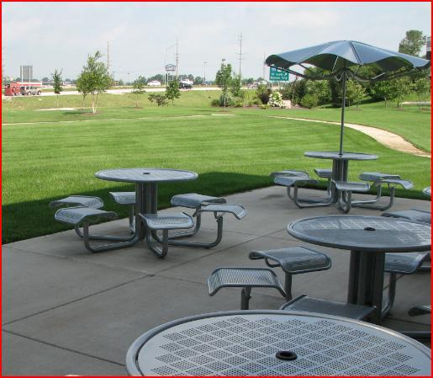

- Stare at that object 20 feet away for the full 20 seconds – it takes the full 20 seconds for the eyes to relax.

- This is a rest break for the eyes.
- Get up, stretch & drink water.

- Water helps keep the body & eye tissues hydrated.

- If you can’t leave your workstation, just make a point to look out the window. This helps keep eye tissues flexible & oxygenated.

- Also, keep the screen clean. Fingerprints & dust can actually cause more stress to already strained eyes.
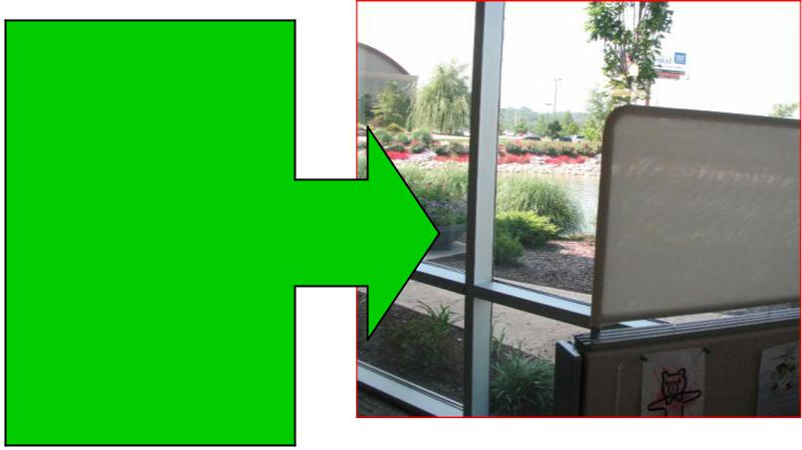

- Drink water often. This keeps the body, and eyes, hydrated & healthy.

- Computer users blink often when working. Eventually, tear ducts dry up, resulting in dry corneas.

- A dry cornea can cause blurred vision and dry eyes.

- Stay away from drinks with excessive sugar or caffeine, as these substances can dehydrate the body.
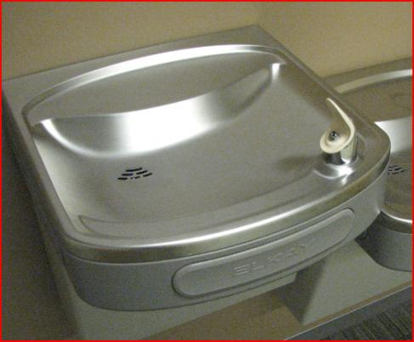

Every 20 minutes, take a look out the window for 20 seconds!

