Tool Box Talk - Clearing Snow and Ice Safely
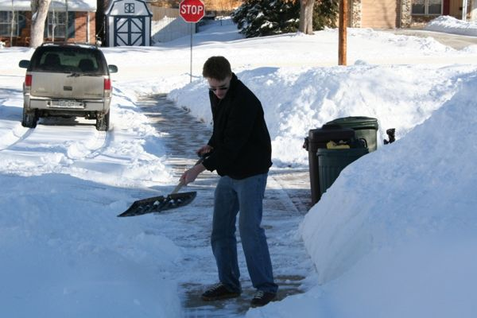
Heart attacks, back strain and muscle soreness are just a few of the problems attributed to shoveling snow. Here are a few safety tips for snow shoveling and blowing.
* If you've ever had a heart attack, if you have heart disease, high blood pressure or high cholesterol, you probably don't want to do the shoveling yourself. At the very least, you should consult your doctor before attempting it. Know the warning signs of a heart attack including chest, shoulder or neck pain, dizziness, fainting, shortness of breath, or nausea. If you think you're having a heart attack, seek medical assistance immediately.
* Smokers may want to resort to a snow blower - and certainly you should never smoke while shoveling. Tobacco smoke constricts blood vessels just as cold air does; the combination can be dangerous.
* Caffeinated products are strongly discouraged as well. The caffeine may increase your heart rate and cause your blood vessels to constrict, just like smoking does. Water is obviously the best to rehydrate, but if something hot is needed, drink hot chocolate or herbal tea!
* Dress in several layers so you can remove a layer as needed.
* Warm up your muscles before shoveling, by walking for a few minutes or marching in place. Stretch the muscles in your arms and legs, because warm muscles will work more efficiently and be less likely to be injured.
* While shoveling stand with your feet about hip width for balance and keep the shovel close to your body. Bend from the knees (not the back) and tighten your stomach muscles as you lift the snow.
* Avoid twisting movements. If you need to move the snow to one side, reposition your feet to face the direction the snow will be going.
* Most importantly  listen to your body. Stop if you feel pain!
This toolbox topic was reviewed by ______________________________________ on ___________________________ with the following employees:

