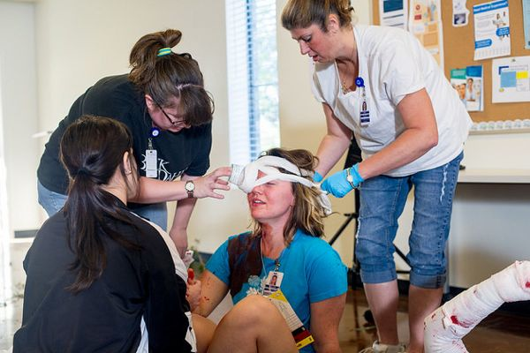
Emergency Preparedness
If you've ever been the first one on the scene at an automobile accident or have been working next to someone who had a tramatic injury at work then you know how important it is to know what to do.
So often in the stress of the situation we forget some of the basics. This can be such a stressful time and your desire to help in a hurry mysteriously "fogs" your brain of the basics. That's why it is so important to know some of the basics of emergency response.
Today we'll review just some of the basics that each of us should know for our workplace. Let's take the following quiz and let me know via raising your hands if you know the answer then we'll go through them one by one.
Presenter's Note: Ensure you know the correct answer for each prior to presenting this toolbox and choose someone different for each answer.
- From right here, where is the nearest phone to call emergency services?
- What number do you call for emergency services?
- From right here, where is the nearest fire extinguisher?
- From right here, where is the nearest exit?
- Do you know where you are to meet if we have to evacuate?
- From right here, where is the nearest defibulator?
- Who knows how to use a defibulator?
- From right here, where is the nearest bloodborne pathogen kit?
- Who knows how to perform CPR?
- What are the signs of a stroke?
- What are the signs of a heart attack?
- If the power were to suddenly go off right now, what should you do?
- If very severe weather was to suddenly approach, what should you do?
- From right here, Where is the nearest first aid kit?
These are just a few things that each of us should know while here at work. We aren't all necessarily first responders, but we can certainly help and may be called upon to do such if a coworker close to you has a tramatic event.
Think about the answers given here today. I'd even suggest that you do the same quiz at home and with your family. Statistically you are more likely to be exposed to an emergency outside of the workplace rather than here.
This toolbox topic was reviewed by ______________________________________ on ___________________________ with the following employees:

