Tool Box Talk - Lifting Safely - Prepare
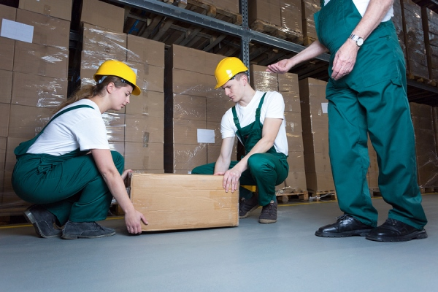

Each day in some form or fashion you do lifting in this facility and at home. Lifting safely is one the most important things you can do to protect your back throughout your lifetime.
Lifting Is a Major Cause of Job-Related Back Injury
- Lifting too much, or lifting improperly, puts too much strain on the back.
Avoid Lifting Manually When Possible
Test the weight and stability of the object you want to move by lifting one corner slightly. If it's too heavy for safe manual lifting:
- Use material handling aids like dollies, hand trucks, or forklifts
- Get another person to help you lift
Plan and Prepare Before You Lift
- Stretch and bend gently to loosen muscles.
- Choose the straightest, flattest, clearest route to your destination.
- Remove anything from the route that could trip or block you.
- Wear sturdy shoes with nonskid soles, gloves to provide grip, and clothing you won't trip over.
This toolbox topic was reviewed by ______________________________________ on ___________________________ with the following employees:

