Tool Box Talk - Wall Openings
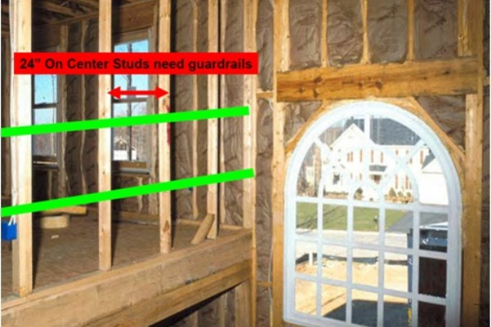
1) Discuss how wall openings need to be protected.
2) Give this TOOL BOX TALK.
Tips for guarding windows:
According to preliminary 2007 fatality data from the Bureau of Labor Statistics (BLS), there were at least 442 construction worker fatalities during 2007 as a result of falls from all causes. Construction falls can be prevented. Educate workers on the following tips to prevent falls on your site.
- Almost all construction sites have unprotected wall openings at some point during construction. This is common between non load bearing stud walls on residential sites.
- All wall openings wider than 18" must be guarded.
- Guardrails need to be installed on wall openings where the outside bottom edge of the wall opening is 6 feet or more above a lower level. If the inside bottom edge of the wall opening is less than 39 inches above the walking/working surface guard rails are needed.
- Install guardrails at 42" ± 3" above the walking/working surface and mid rails at 21".
- Guard rail systems must be capable of supporting a 200lb force in any direction at any point along the top of the rail.
- When workers are working at elevated levels (for example, a worker on stilts), the height of the toprail must increase to an amount equal to that of the stilts. This ensures that workers on stilts can not fall over the guard rail.
Questions to start discussion:
1. When do you need to guard wall openings?
2. When should the guard rails be removed?
3. At what height should the guard rails be placed?

This toolbox topic was reviewed by ______________________________________ on ___________________________ with the following employees:

