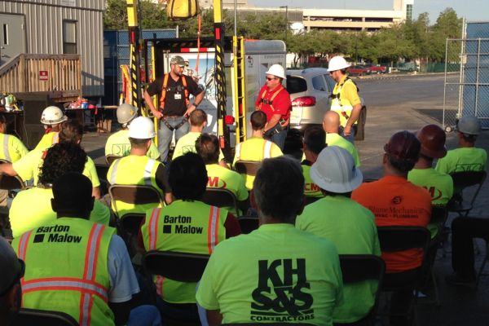
Tool Box Talk - What IS Safety?
When posed with the question "what is safety", the answer may appear obvious. One person's answer or perception of safety may be quite different from another's. This perception of safety is often based on one's own occupation and or experiences. If you work in industry or construction, your perception of safety may be comprised of a combination of OHS Regulations, site regulations, company policy and the latest Toolbox Talk. If you're in the aviation industry, your perception would find basis from Transport Canada and the Canadian Aviation Regulations.
How about someone that works in a small business or some other occupation were safety regulations, rules and procedures are simply not in place and are rarely if ever spoken of? What level of risk do these people navigate through on a daily basis? Take driving for example; many of us drive, we jump in or cars and trucks daily and take off down the road. Many of us have driven for years without so much as a speeding ticket. When you consider the number of vehicles on the road, it's amazing how relatively few road accidents there are.
The laws, regulations and rules of the road are probably the most universal example of a system of safety in our society. A singular system we can all reference a perception of safety on. We take driving for granted, we do it automatically.
So then, back to the question, "what is safety?" Is it a set of rules and regulations or is it a perception. Do you feel "safe" while driving? Maybe so, at times more or less than others.
Rules, regulations and procedures provide the lattice or structure for which we reference our perception of safety on. When we add a regulation or another procedural rule as the recommended remedy to an incident, we add complexity to our safety system. However, rules, regulations and procedures don't think, people think. Like driving, we do it automatically. Safety is created and exists in our minds.
The more we learn, practice, share and mentor each other on the aspects of safety in our workplace and lives, the safer we become. Not by adding rules, rather by sharing experiences. By sharing and creating a broad and increasing knowledge of safety, we create and sustain a vibrant safety culture. A culture that encourages and supports one another to think safety, thereby empowering each individual to navigate safely through an ever expanding set of circumstances and variables encountered through the workday and our daily lives.
This toolbox topic was reviewed by ______________________________________ on ___________________________ with the following employees:

