Tool Box TIPS

KEEP REACH CLOSE

Facilitator / Leader Tasks Before the Tool Box Talk (TBT):
- Read through this TBT guide.

- Walk the job site to find ergonomics examples based on the TBT. If possible, take photos of “safe” and “unsafe” examples at the site to be used during the TBT.
- Write down discussion questions to ask the group. Fill them in on page 2 “Other Questions.”

Learning Goals: After discussing this training topic, workers will have gained a general understanding of:
- Injury risks related to reaching.

- Ergonomic solutions for reducing reaching.

TRAINING CARD:

⃝ KEEP YOUR REACH CLOSE

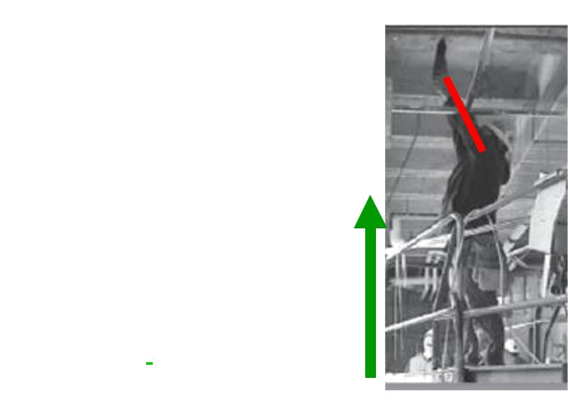
Reaching out adds extra strain to your shoulder and makes it harder to grip, especially when the wrist is bent.

In the Air: Move your lift, ladder, or feet to get as close to the task as possible.

On the Floor: Keep the floor free of objects so lifts, ladders, & hoists can be moved around.

Talk to your co-worker above to
keep his reach close to his body. _{Get closer to the task}

KEEP YOUR REACH CLOSE

NOPE ☹ YEP ☺

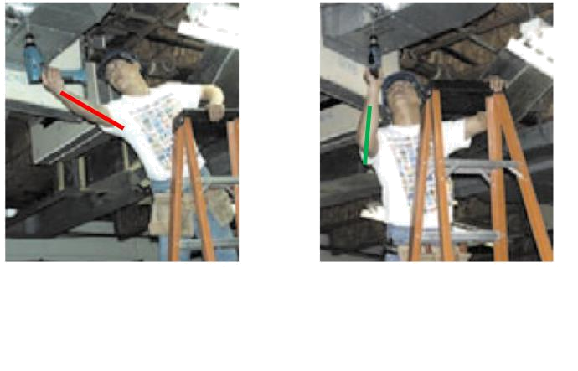

When possible,

use the lift or ladder to your advantage. Adjust its position to get close to the task.

TRAINER’S TALKING POINTS:

Why should we talk about reach?

Reaching involves your shoulders, low back, arms, and hands. When we reach with our elbows fully extended and hands away from our body we are at risk for straining our shoulders and low back.

Reaching out of a normal range increases the force on our joints due to basic physics. It also makes it harder to grip tools, especially when reaching with the wrist bent. In most cases, working outside of the reaching comfort zone makes us have to work harder than if the task were closer and involved less reaching.

The shoulder is a very mobile joint and is prone to injury when moved outside of its normal range. Injuries that you may have heard about the shoulder include shoulder strain, bursitis, biceps tendonitis, and rotator cuff tear.

Tool Box TIPS

TRAINER’S TALKING POINTS

The photos on your training card with red lines on the arms show examples |  | Awkward Reaching
of workers reaching outside of their normal range.
Discussion Question: | During what work tasks do you reach the most? Can
you share some examples?
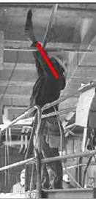
Other Questions:_____________________________________________

Training Note: Here are examples of hazards in different construction trades. Choose your trade or one that is similar
to your group’s line of work that can be used as hazard examples.

 | Trade | Reaching (Awkward Posture) Hazards
 | Carpenter - | Operating a screw gun overhead with the arm fully
 | Drywall | extended and the wrist bent.
 | Floor Layer | Spreading adhesive using a hand trowel with the arm
 |  | fully extended out to the side and the wrist bent.
 | Sheet Metal | Prepping duct parts on the floor while bending (the
 | Worker | back) and reaching to work on them.

Discussion Questions: What are some ways that you setup your work tasks and equipment in order to reduce reaching?

- Does your example always help to prevent reaching?
- Do you have suggestions for keeping your tasks close to you?

- Other Questions:_____________________________________________

Now let’s put this information into practice. When possible, during work:
In the Air - Move your lift, ladder, by adjusting its position to get as close to the task as possible.

On the Floor - Keep the floor free of objects so lifts, ladders, & hoists can be moved around. Where possible, adjust by moving your feet instead of bending or reaching.

Communicate - Talk to your co-worker above to give him feedback about his work position to help keep his reach close to his body.

In summary, when possible, try to work with your hands below your head and close to our body to reduce your risk of shoulder strains and back discomfort. Consider ways to move close to the task, keep the work area free of obstacles, and talk with each other to provide constructive feedback about your working position.

