Tool Box TIPS
POSITIONING

Facilitator / Leader Tasks Before the Tool Box Talk (TBT):
- Read through this TBT guide.

- Walk the job site to find ergonomics examples based on the TBT. If possible, take photos of “safe” and “unsafe” examples at the site to be used during the TBT.
- Write down discussion questions to ask the group. Fill them in on page 2 “Other Questions.”

Learning Goals: After discussing this training topic, workers will have gained a general understanding of:
- Unsafe work positions.

- Solutions to improve work positioning.

TRAINING CARD:
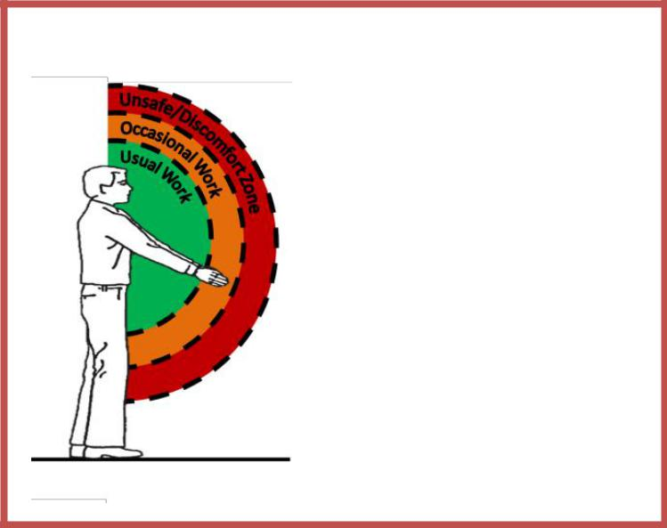
⃝ W.U. Ergonomics TIPS
POSITIONING

Green – Keep the work close (reach out as far as your wrists). Orange – If needed, keep the reach distance as far as your fingertips. Red- Limit the time you work reaching beyond your fingertips to prevent falls and discomfort of back and shoulders.

Prop it up: When possible, use a raised surface (cart, baker scaffold, saw horses) to prep materials near waist height.
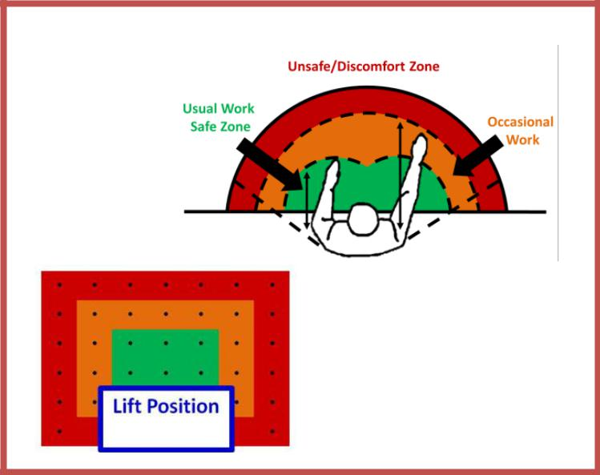

POSITIONING

Move the lift in the best

position for

the work – close to the work tasks.

For safety & comfort, try to position the lift in front of the area you plan to work

without trying to reach too far on either side of the lift.

TRAINER’S TALKING POINTS:

Why should we talk about positioning?

Construction work requires working in high, low, and tight spaces which often forces you to work in an awkward or uncomfortable position. Working in awkward reaching and bent positions can lead to shoulder and back discomfort and possible injury over time.

Demonstration: The training card provides examples of the range of reaching and the point at which the reach is unsafe. Hold your arms straight out in front of you. Look at your hands and wrists while I discuss each of the reach zones on the training card.

The Green Zone shows the ideal location for working with your hands. When possible, try to keep your work tasks as far out as your wrists.

The Orange Zone is for occasional work since it involves more weight on your shoulders and low back since your hands are away from your body. If needed, keep the reach distance as far as your fingertips.

The Red Zone is away from your body so far that it places you at higher risk for falls when in the air and shoulder and back discomfort. Limit the time you work reaching beyond your fingertips.

End of Demonstration

TRAINER’S TALKING POINTS

Discussion Question: Can anyone describe to us an awkward position that they work in or have seen someone work in?
- What does it feel like in your neck, back or arms when working in that position?
- Other Questions:_____________________________________________

Training Note: Here are examples of hazards in different construction trades. Choose your trade or one that is similar to your group’s line of work that can be used as hazards and solutions examples.

 | Trade | Awkward Posture Hazards | Potential Solution
 | Carpenter | Leaning over the side of a scissor lift to | Before starting to install the line of
 | - Drywall | reach and operating a screw gun with the | screws to the side of the lift, move the
 |  | arm fully extended (reaching in the red | lift to re-center it for the next 2 lines of
 |  | zone past the fingertips). | screws to be installed.
 | Floor | Spreading mortar overhead on a wall with | Pre-plan this task by removing all
 | Layer | the bakers scaffold one foot away from the | objects in the path of the bakers
 |  | wall due to buckets on the floor below | scaffold. Having an open path allows
 |  | (reach in the red zone, past the fingertips). | you to work closer to the task.
 | Sheet | Prepping duct parts on the floor while | Pre-plan this task by setting up a waist-
 | Metal | bending the back and reaching to work on | height workstation on extra materials,
 | Worker | them. | a cart, or saw horses.

