Tool Box TIPS
POWER TOOLS

Facilitator / Leader Tasks Before the Tool Box Talk (TBT):
- Read through this TBT guide.

- Walk the job site to find ergonomics examples based on the TBT. If possible, take photos of “safe” and “unsafe” examples at the site to be used during the TBT.
- Write down discussion questions to ask the group. Fill them in on page 2 “Other Questions”.

Learning Goals: After discussing this training topic, workers will have gained a general understanding of:
- Hand injuries related to power tool use.

- Principles of choosing comfortable hand tools.

TRAINING CARD: TRAINER’S TALKING POINTS:

⃝ W.U. Ergonomics – TIPS POWER TOOLS:
Reducing Forceful Gripping & Hand-Arm Vibration

1. Minimize Force: Choose tools that will do the job easier than the alternative.


Which tool is
=
better for the

task at hand?

Let the tool do the work for you.


Maintain a firm grip, not too tight.

Work in a comfortable position.
Adjust your position or task height.
Use a drill bit extension as needed.

2. Minimize Vibration

Choose power tools with low vibration levels ≤5m/s² Reduce time using the tool by alternating tasks. Wear vibration dampening gloves or wrap handles. When possible, attach tool to a fixture or suspend it.

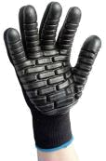

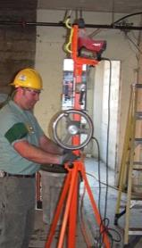
Vibration
Vibration |  | Over-head
dampening |  | Drill Press
gloves

3. Maintain Tools
Change blades before they become too dull. Wipe & oil blades and oil joints to prevent rusting.

Why should we talk about power tools?

Minimizing forceful gripping and hand-arm vibration from operating power tools reduces your risk of musculoskeletal disorders (MSD) like carpal tunnel syndrome and tennis elbow.

Reduce your risk of MSD injury by following these 3 guidelines as best you can.

- Minimize Force: Choose tools that will do the job easier than the alternative.
Choose the tool that is better for the task at

hand when you have a choice between using one tool or the other.

Let the tool do the work for you.

Maintain a firm grip, not too tight.

Work in a comfortable position.

Adjust your position or task height.

Use a drill bit extension as needed.

- Minimize Vibration: Choose power tools with low vibration levels (Less than 5m/s²).

Reduce time using the tool by alternating tasks. Wear vibration dampening gloves or wrap handles. When possible, attach tool to a fixture or

suspend it.
- Maintain Tools

Change blades before they become too dull. Wipe & oil blades and oil joints to prevent rusting.

Tool Box TIPS

POWER TOOLS

TRAINER’S TALKING POINTS

Print a copy of this sheet for your workers to use a discussion guide for this portion of the talk. Bring 2 power tools to the talk to discuss their design qualities for use during the current job.

Discussion Questions:

Tool Design Quality | If Yes, See |  | Solutions
 | Solutions
For rotary based tools: | Yes or No |  | When possible, use power tools with a built in ratcheting system
 |  |  | that does not jerk/twist the hand/wrist.
Does the tool jerk the
hand or wrist / over- |  |  | Do you have other solution ideas?________________________
torque it?
Does the tool weigh | Yes or No |  | When possible, operate the tool with 2 hands.
more than 2 lbs? |  |  | Do you have other solution ideas?________________________
Does the tool vibrate so | Yes or No |  | Ways to reduce your exposure to vibration in tools include:
much that the hand |  | 1. |  | Purchase tools with built-in vibration dampening.
and arm shake when |  | 2. |  | Use a jig or fixture to hold the tool in place when operating it.
using it? |  | 3. |  | Wrap the tool hand with vibration dampening materials.
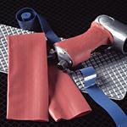

4. Wear anti-vibration gloves.
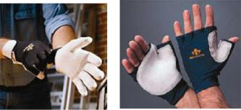

Full finger gel is helpful for high impact and gripping power tools with full finger contact.

Half finger gloves are good for moving between power tool use and fine dexterity tasks (Ex. drilling and threading fasteners).

