 | Injury & Illness Prevention Program  Job Safety Analysis Form

Picture of task/equipment: | Task: |  | Portable band saws
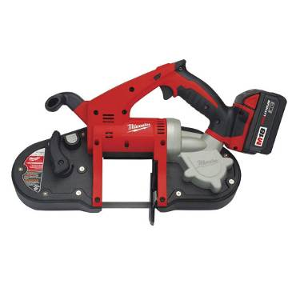 | Name of  Shop or Dept: |  | OCH Maintenance, UA
 | Job Title(s): |  | Building Maintenance, Plumbers
 | Analyzed by: |  | M. Williams
 | Date: |  | 05/01/13
Required PPE:
Work boots hearing protection safety glasses Gloves
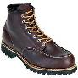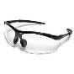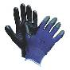
Required/Recommended Trainings:
STF Safety Equipment safety precautions
TASK | HAZARDS | CONTROLS
Operating a portable band saw  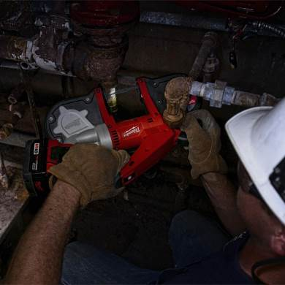 | Lacerations  Amputations  Struck By’s  Slips  Trips  Falls | - Don PPE, including safety glasses, work boots, gloves and hearing protection (When working in noisy areas).  - Always unplug or remove battery pack before removing blades or accessories.  - Do not wear loose clothing. Keep jewelry and hair out of reach of moving parts.  - Before use check for damage to blade and/or teeth. Cracked and damaged blades can vibrate loose and become projectiles.  - When cutting do not hold piping below or in line of blade.  - Always cut away from the body.  - Never force the tool as it can bind and break resulting in flying objects.  - Extended use can create vibration; gloves will help reduce vibration to hand and arms. Take breaks when working on long projects.  - Do not touch blade immediately after use as it will be hot.  - Never attempt to cut through piping that may be insulated with possible asbestos containing Material (PACM), only those trained in asbestos should work around PACM or ACM.

