Picture of task/equipment: | Task: | Operating an 18-inch Band Saw
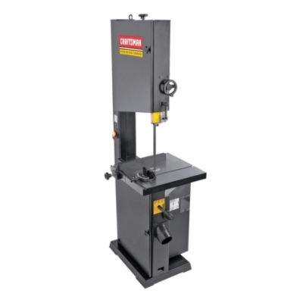 | Name of Shop or Dept:
 | Job Title(s):
 | Analyzed by:
 | Date:
Required PPE:
- Safety glasses
- Face shield

Required/Recommended Trainings:
1. Operation of band saw
TASK | HAZARDS |  | CONTROLS
- Check condition of blade. | Loose, obstructed, or dull blades or guards create pinching hazards. |  | Avoid contact with blade teeth.
2. Align materials flat on table. | Pinching fingers or hand. |  | Keep fingers and hands away from pinch points.
3. Adjust guard to no more than ¼ inch above top of material. | Cutting fingers and hands. |  | Avoid pinch points between guard and housing and between guard and material.
4. Start blower and saw. | Flying sawdust. |  | Keep fingers and hands away from blade.  Use push bar for smaller materials.
 |  |  | Wear safety glasses or face shield.

 | Injury & Illness Prevention Program  Job Safety Analysis Form

