Be Prepared!
An Emergency Is No Time To Hesitate Or Panic!
- Know how to recognize – and activate – emergency alarms
- Know your responsibilities under the emergency response plan for your work site or office
- Act quickly when you hear an alarm
- Leave the area immediately unless instructed not to
- Use emergency exit stairs – DO NOT USE THE ELEVATORS
- Close windows or doors not needed for escape
- Alert other employees to the emergency
- Assist any disabled employees who need help escaping
- Leave the area by the closest safe exit
- Continue outside of building or work area
- Go to your assigned “safe place” or gathering point
- Employees are responsible for their visitors
- Do not block the path of emergency response crews or vehicles
- Stay in your assigned “safe place” or gathering point so no one fears you are left behind or in danger
- Follow instructions about where to go – and when

Avoid Panic
- Walk - Do Not Run
- Do Not Waste Time
- Avoid Using the Telephone
- Do Not Talk
- Do Not Push or Shove
- Comply With Instructions
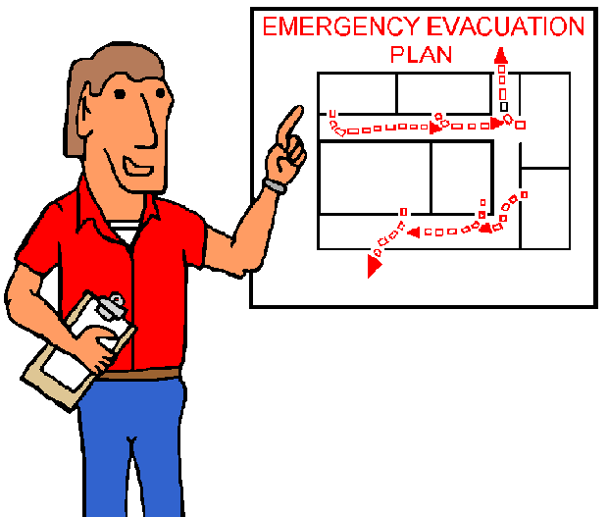
- Do Not Smoke
- Keep Exits Clear
- Relocate Only If Required

What Can I Do?
- Assess your own workspace and other spaces you frequent
- Decide in advance what you will probably do and practice it

