Picture of task/equipment: | Task: |  | Chemical use
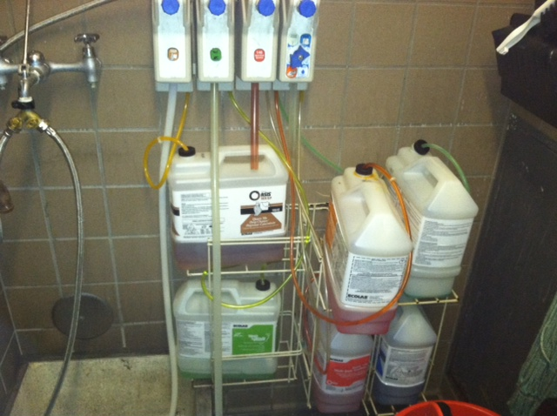 | Name of Shop or Dept: |  | Dining Services, Rooms
 | Job Title(s): |  | All
 | Analyzed by: |  | M. Williams
 | Date: |  | 01/30/13
Required PPE:
Face Shield Neoprene, Butyl, Rubber gloves Chemical resistant Apron
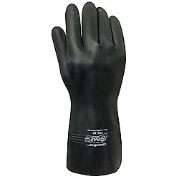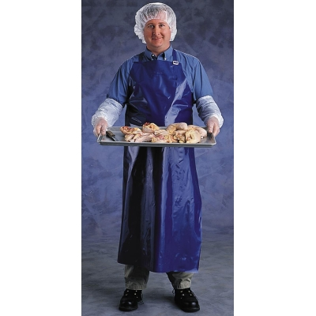
Required/Recommended Trainings:
Hazard Communication
TASK | HAZARDS | CONTROLS
Mixing chemicals for operational use  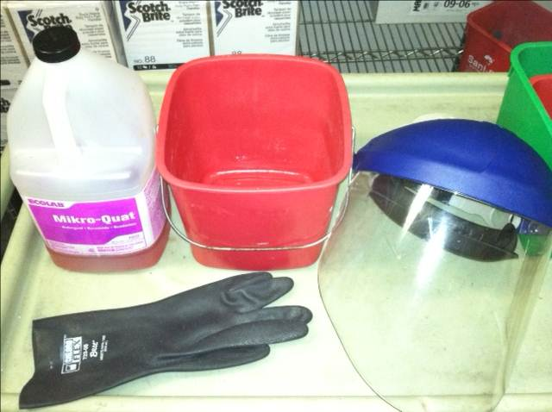 | Chemical Burns  - Face  - Eyes  - Skin  Ingestion  Inhalation | - Always review MSDS prior to mixing chemicals. Always check for incompatibles, such as acids and bases.  - Never mix incompatible chemicals; Mixing incompatibles can increase hazards, such as creating a vapor and inhalation hazard from mixing acids with bases  - Don PPE to minimize risk of exposure to skin  - Only use chemicals that you have been trained on using and are familiar with.  - When using an acid product (bathroom cleaners, lime based cleaners) always add acid to water, never the other way around.  - Only use chemicals that are properly labeled and do not use more than necessary.  - Immediately replace cap/lid as soon as you are done with the chemical.  - Use a compatible container (HDPE/mop bucket) with the chemical when mixing.

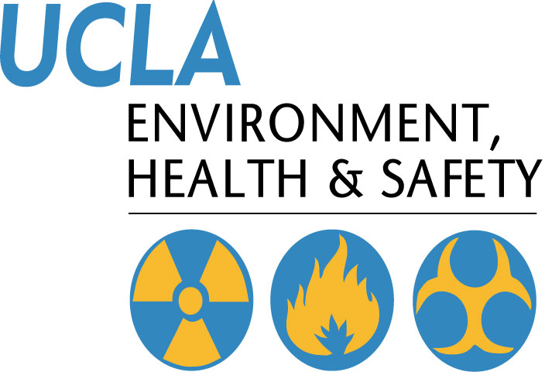 | Injury & Illness Prevention Program  Job Safety Analysis Form

