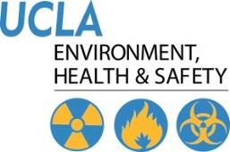 | Injury & Illness Prevention Program  Job Safety Analysis Form

Picture of task/equipment: | Task: |  | Bathrooms
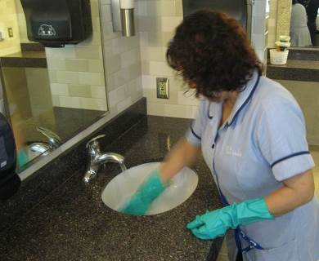 | Name of  Shop or Dept: |  | OCH-Rooms
 | Job Title(s): |  | Custodian, Senior & Assistant
 | Analyzed by: |  | M. Williams
 | Date: |  | 05/30/13
Required PPE:
Non-Slip Shoes |  |  |  |  | Neoprene Gloves
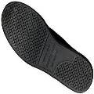 |  |  |  |  | 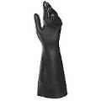

Required/Recommended Trainings:
STF Safety |  | Ergonomics

TASK | HAZARDS | CONTROLS
Sink Cleaning  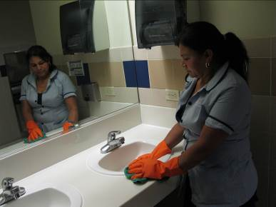 | Slips  Trips  Falls  Sprains  Strains  Struck By’s | • Don PPE, including Non-slip shoes and nitrile/Vinyl gloves.  • Remove any large debris from the sink and/or counter prior to beginning work.  • Use chemical disinfectant in a bottle with a pour spout, this will avoid the need to spray cleaner; ensure the bottle is labeled with chemical name, hazards and manufacturer.  • Note; if chemicals are sprayed, then face protection including a goggles and mask must be worn to prevent absorption/ingestion exposure.  • Let disinfectant dwell for time specified by manufacturer to ensure bacteria is killed.  • Use scour pad to scrub clean the faucet and sink area; alternate hands to minimize fatigue.  • When cleaning underneath the sink, squat down using legs or kneel to avoid back strain.  • Avoid over reaching from left to right as this can result in a loss of balance.  • Be aware of counter tops and corners as you clean and stand back up to avoid hitting this area with head or other body part.  • If water gets on surrounding floor, clean up immediately and place a wet floor sign until area has dried.

