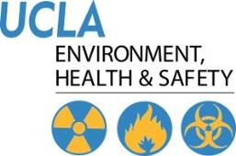 | Injury & Illness Prevention Program  Job Safety Analysis Form

Picture of task/equipment: | Task: |  | Bathrooms
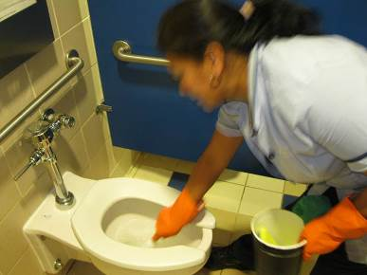 | Name of  Shop or Dept: |  | OCH-Rooms
 | Job Title(s): |  | Custodian, Senior & Assistant
 | Analyzed by: |  | M. Williams
 | Date: |  | 05/31/13
Required PPE:
Non-Slip Shoes |  |  |  |  | Nitrile Gloves
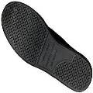 |  |  |  |  | 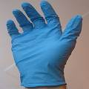

Required/Recommended Trainings:
STF Safety |  | Ergonomics

TASK | HAZARDS | CONTROLS
Cleaning Toilets  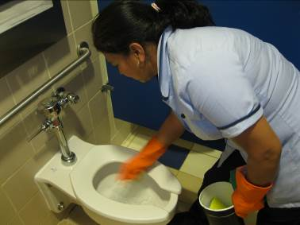 | Slips  Trips  Falls  Sprains  Strains | • Don PPE, including Non-slip shoes and nitrile/Vinyl gloves.  • Ensure bathroom is closed for cleaning, post closed signage and wet floor signs.  • Remove any loose debris from around the toilet.  • Lift up toilet seat and rest on the toilet tank or flusher, then flush toilet, place back down.  • Dispense toilet bowl cleaner underneath the rim of the toilet and let sit per manufacturer’s recommendations to kill bacteria.  • Bend with the knees and at the waist (hinge), do not roll the spine down as this can cause back pain.  • Clean toilet bowl with toilet brush/scrubber around the sides and down into the water.  • Alternate hands to minimize fatigue in the same hand.  • Using a rag or scour pad, clean around the toilet and the seat.  • Flush toilet to remove any residue and chemical left in toilet water.

