Driving and Cellular Phones

Does using a cellular telephone while driving cause more accidents?
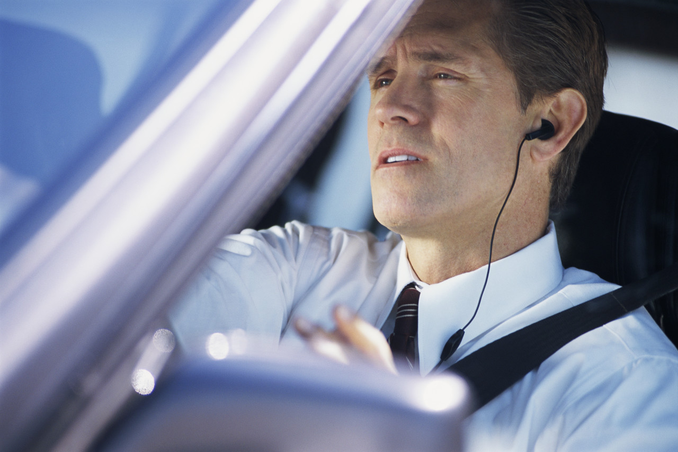
In general, driver distraction is one of the leading causes of traffic accidents. Using and talking on a cellular phone requires a large amount of attention and can be a contributing factor to accidents. Some studies have reported findings that there are higher incidences of accidents when drivers use a cellular telephone and other reports have concluded that cell phone usage does not result in higher accident rates. Nevertheless, the fact still remains that using a cellular telephone is one of many distractions a driver faces. In other words, concern about driver distraction should not be limited to cellular telephones.
What skills does a driver use?
Skills needed by a driver include:
Skill | Examples
Visual (Seeing) | - watching the road (in front and around the vehicle)  - using mirrors, shoulder checks  - checking gauges, speedometer, etc.
Auditory (Listening) | - squealing of brakes,  - the sirens of an emergency vehicle  - vehicle sounds
Biomechanical ('Doing', Activity, Hand-eye coordination) | - turning the steering wheel  - activating signals, headlights, horn, etc.  - pressing the accelerator, brakes, clutch
Cognitive (Thinking) | - anticipating any future movements  - assessing situations such as movement of other vehicles, weather conditions, etc.  - preparing to avoid hazards

To use a cellular telephone, the operator also needs all of these skills:
- Visual - locating correct buttons, scanning screen
- Auditory - listening to conversation
- Biomechanical - pressing buttons, holding phone
- Cognitive - engaging in conversation
What are some common causes of driver distraction?
It is not known how much distraction a driver can "handle" before he or she loses focus on the road. We probably have all seen examples of activities that can distract drivers such as:
- Eating/Drinking/Smoking;
- Reading (including looking at a map, book, etc.);
- Applying makeup/shaving;
- Adjusting radio/cassette/CD, DVD players, climate, or other controls;
- Adjusting features such as pedals or steering wheel;
- Watching a person, object or event outside the vehicle;
- Moving objects in the vehicle (food containers, insects, etc.);
- Talking with other people, especially if the driver turns to those in the back seat of the car;
- Dialing and talking on a cellular telephone; and
- Using CB radio or other communication devices.
Newer in-vehicle technologies such as those below will only add to the demands on a driver:
- Advanced features of cellular phones and other wireless communication devices including Internet, e-mail, fax, etc. (mobile office);
- Other wireless devices such as laptop computers, palm pilots, etc.;
- In-vehicle navigation systems; and
- Night vision systems.

What are some 'good' driving tips?
Most importantly, pay attention. Accidents occur because drivers were not aware of the conditions around them. Be aware and know that distractions can come from many sources at any time.
In general:
- Be well rested.
- Do not consume alcohol, drugs, medications or other substances that may affect driving.
- Try not to think about personal or business matters, especially those that are upsetting.
Before leaving:
- Stow belongings properly.
- Adjust seat, mirrors, steering wheel, climate controls, etc.
- Select a radio station or have the tape/CD in the player.
- Plan your route, check the map or read the directions.
While driving:
- Pay attention.
- Keep distractions to a minimum (eating, drinking, smoking, adjustment to radio, cell phone use, etc.).
- Be aware of changing driving conditions such as the volume of traffic, weather, etc.
- Do not reach for items that have fallen or shifted unless absolutely necessary and can be done safely.
- Do not write notes while driving and/or talking.

