Electrical Safety (Part 3)

What is a Ground Fault Circuit Interrupter (GFCI)?
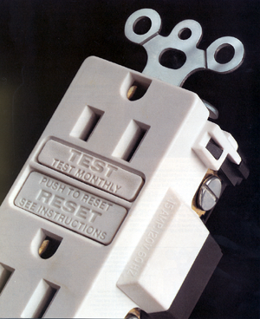
In a normal three pin outlet, current flows only between the two vertical slots; the ground hole centered blow the slots should never carry current. When an appliance is plugged into the receptacle and working properly, all current flows from the narrow slot on the right (the "Hot"), into the appliance and returns through the wider slot on the left (the "neutral"). The Ground Fault Circuit Interrupter senses the flow of current going to the appliance from the "Hot" slot and returning from the appliance in the "Neutral" slot. These current flows should be exactly the same. If there is a difference of more about 4 milliamps between them, the current must also be unintentionally flowing into the ground hole and the GFCI opens the circuit as quickly as one-thirtieth of a second. GFCI protection is available in outlets or circuit breakers. A GFCI outlet will protect itself and all outlets connected downstream and can be tested and reset locally. A GFCI circuit breaker will protect the entire circuit but must be tested and reset at the breaker panel.

Note that modern appliances with only two blades on their power cord are specially designed to prevent accidentally energizing the exterior of the appliance. Sometimes referred to as "double insulated", these appliances typically have cords that can only be inserted into the outlet in one direction. You should be very careful around older or antique electrical products, as many of the modern electrical safety features have not been incorporated in their design. Especially dangerous are old televisions, radios, musical instrument amplifiers and electronic organs. Several musicians have been seriously injured and killed using improperly grounded equipment.

Another, more complex, advance has been made in electrical safety and now Arc Fault Circuit Interrupters (AFCI) are required by the NEC in all dwelling bedroom circuits. AFCI are circuit breakers (outlets are not yet available) with embedded microcontrollers that monitor the circuit for distinctive fluctuations in current flow caused by arcing faults. They also provide GFCI functionality but at a higher "leakage" current, about 75mA. While this is an improvement over a non-GFCI circuit, it is not a substitute for GFCI circuits where required by the NEC.

When and how do I test the Ground Fault Circuit Interrupter (GFCI)?
Test the GFCI monthly. First plug a "night light" or lamp into the GFCI-protected wall outlet (the light should be turned on), then press the "TEST" button on the GFCI. If the GFCI is working properly, the light should go out. If not, have the GFCI repaired or replaced. Reset the GFCI to restore power.

If the "RESET" button pops out but the light does not go out, the GFCI has been improperly wired and does not offer shock protection at that wall outlet. Contact a qualified electrician to correct any wiring errors.

