Excavations – Part 1

Introduction

A cave-in can trap you within seconds and kill you within minutes. Two cubic yards of soil weigh approximately 6,000 pounds ( 2721 kg). If you’re buried, you’ll suffocate in less than three minutes and if you do survive, the weight of the soil is likely to cause serious internal injuries. Cave-ins aren’t the only hazard in excavation work. Lack of oxygen, toxic fumes, explosive gases, and buried power lines may also be present. Unfortunately, many of those who perform excavation work still think that it’s too expensive or takes too much time to provide appropriate safeguards.

Plan Before You Dig

Planning reduces the chance that something will go wrong when you start the job. Consider the following before you start excavating:
- Surface debris near the excavation site that could create a hazard
- Weather conditions
- Stability of soil at the excavation site
- Location of underground utility lines
- Overhead power lines
- Vehicle traffic near the excavation site
- Stability of structures adjacent to the excavation site
- How employees will get in and out of the excavation
- Vehicles and other mobile equipment that will operate near the excavation
- Possibility of atmospheric hazards in the excavation
- Possibility of water accumulation in the excavation
- How to respond to emergencies
- How to protect people from falling into the excavation

The Role of the Competent Person

A designated competent person who has training in soil analysis, protective systems, and federal or state regulatory requirements for excavations must be on site to classify the soil, select a protective system, oversee installation, and inspect the system after installation. If there are no existing hazards, the competent person can leave the site until the protective system is moved, at which time soil conditions could change requiring the competent person to be present. The competent person can only be gone for a short time while the trench is open — new hazards could arise that may require the competent person’s judgment. The competent person must be knowledgeable about the type of soil excavated and the protective system used and must inspect them daily for signs of instability, damage, or other hazards; any changes must be approved by the competent person. Inspections are also necessary after heavy rain or activities such as blasting that may increase the risk of a cave-in. The competent person must have authority to immediately correct the hazards and to order workers to leave the excavation until the hazards have been corrected. An employee who is trained and can identify excavation hazards but doesn’t have the authority to correct them is not a competent person.

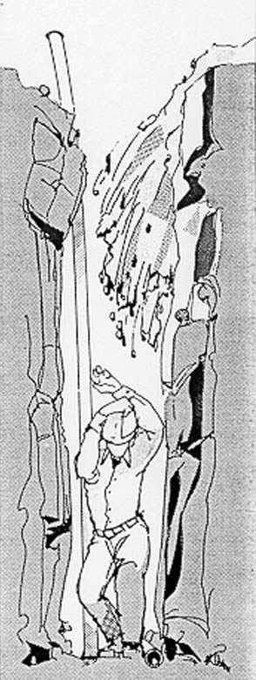
How Cave-Ins Occur

Undisturbed soil stays in place because of opposing horizontal and vertical forces. When you create an excavation, you remove soil that provides horizontal support. Soil will eventually move downward into the excavation. The longer the face (a side of the excavation) remains unsupported, the more likely it is to cave in.

Stability and Soil

The type of soil is one of the factors that helps determine the stability of an excavation and the chance that it will cave in. There are three soil types that you may encounter in Oregon:
- Type A soil is very stable. Clay is an example.
- Type B soil is less stable than type A soil. Crushed rock, silt, and soils that contain an equal mixture of sand and silt are examples.
- Type C soil is less stable than type B soil. Gravel and sand are examples.

Soil has other qualities that affect its stability. These include granularity, saturation, cohesiveness, and unconfined compressive strength. Granularity refers to the size of the soil grains; the larger the grains, the less stable the soil. Saturation means how much water soil will absorb. Cohesiveness means how well soil holds together; clay is a cohesive soil. Un-confined compressive strength is determined by a test that shows how much pressure it takes to collapse a soil sample. For example, type A soil must have an unconfined compressive strength of at least 1.5 tons per square foot.

