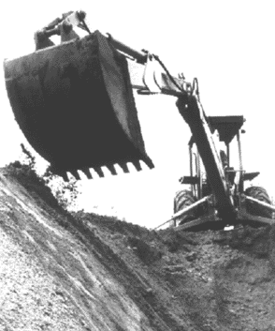
Excavations – Part 2

Protective Systems

The basic systems for protecting employees from cave-ins are sloping, benching, shoring, and shielding. The system that you should use depends on factors such as soil type and water content, excavation depth and width, the nature of the work, and nearby activities that could increase the risk of a cave-in. The competent person has the responsibility for considering these factors and for determining the appropriate protective system. A registered professional engineer must design protective systems for all excavations that are more than 20 feet deep.

Sloping and Benching

Sloping and benching provide protection by removing material from the faces of an excavation at an angle to its floor. The flatter the angle, the greater the protection. A slope not steeper than 1½ feet back for every foot of depth is safe for any soil type. However, a registered professional engineer must determine the angle of slopes in trenches that are deeper than 20 feet. Benches are cuts in the slope that give it a stair-step appearance. There are two types of benches: simple and multiple. Benched slopes are permitted only in type A and type B soils. Rain, vibration, and pressure from heavy equipment can make soil unstable and increase the risk of a cave-in. Sloped or benched excavations that show signs of cracks, bulges, or clumps of soil that fall away from the faces must be inspected by a competent person. Employees must immediately get out of the excavation and stay away from the area until the competent per-son determines it is safe to enter.

Shoring and Shielding

Shoring and shielding systems prevent cave-ins in excavations with or without sloped or benched faces. The safest way to install and remove them is from outside the excavation. Shores are vertical or horizontal supports that prevent the faces of an excavation from collapsing. Vertical shores are called uprights. They’re easy to install, relatively inexpensive, and often used in stable soil or in shallow excavations that have parallel faces. Vertical shores must be sized for the excavation’s dimensions and soil type.

Horizontal shores are called walers. Walers are often used when unstable soil makes sloping or benching impractical and when sheeting is necessary to prevent soil from sliding into the excavation. Shields provide employees a safe work area by protecting them from collapsing soil. Shields don’t prevent cave-ins but “shield” workers if a face does collapse. They are usually placed in the excavation by heavy equipment. Shoring and shielding systems are available from manufacturers in a variety of dimensions, usually aluminum or steel, or they can be custom-built from tabulated data approved by a registered professional engineer. Manufacturers will also provide tabulated data with their systems that includes engineering specifications, depth ratings, special instructions, and system limitations. Only by carefully studying and understanding the manufacturer’s tabulated data can the competent person choose the correct protective system.

Getting In and Out of an Excavation

An excavation that has a depth of 4 feet or more must have a means for entering and exiting — such as a stairway, ladder, or ramp — within 25 feet of employees; their safety may depend on how quickly they can climb out. When an excavation is 5 feet or more in depth, the stairway, ladder, or ramp must be located inside the protective system. Structural ramps that are used to enter and exit the excavation must have non-slip surfaces and be designed by a competent person. A competent person must also evaluate earthen ramps that are used to enter and exit an excavation.

Materials and Mobile Equipment

Excavated soil, called spoils, piled too close to the edge of an excavation can cause a cave-in. So can heavy equipment. Keep spoils and heavy equipment at least 2 feet from the edge; when possible, use vertical shores or shields that extend above the top of the excavation to restrain spoils. Spoils and heavy equipment that exert an excessive load on ground adjacent to the excavation could cause a cave-in and must be moved. They must be moved back from the edge a distance equal to the depth of the excavation.

Hazardous Atmospheres

Hazardous atmospheres can occur in excavations near landfills, sites contaminated by leaking gas lines or storage tanks, in sewers, and in other confined spaces. If these conditions are possible, a competent person must test for oxygen deficiency (oxygen levels less than 19.5 percent) and hazardous atmospheres before employees enter.

Water Accumulation

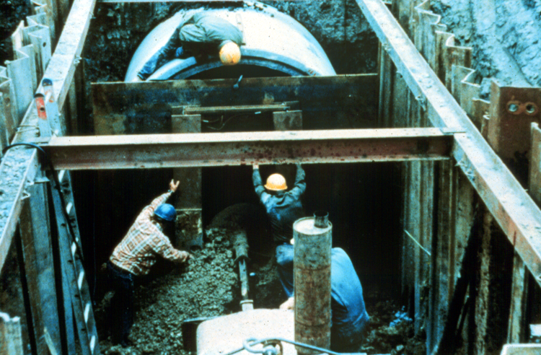
Water makes soil unstable. Employees can’t enter excavations when water has built up unless they are protected from the increased risk. Protection includes specialized support systems and water-removal equipment. A competent person must inspect the excavation and monitor methods used to control water accumulation.

