First Aid Training Is a Lifesaver
Do you know about primary and secondary surveys?
First aid could be required in different circumstances. For example, some medical emergencies are life threatening and others are comparatively minor. That's why you need to know the difference between a "primary survey" and "secondary survey."
A primary survey is for life-threatening injuries. It involves checking the ABCs--airway, breathing, and circulation. In other words, can the victim get air into their lungs, is the victim actually breathing, and is there a pulse? If the answer is "no," rescue breathing or CPR is required. During a primary survey the person giving first aid should also look for profuse bleeding or shock.
A secondary survey is for other medical and injury-related problems. During a secondary survey, the first-aid giver checks for vital signs, does a quick head-to-toe check, asks the victim about the accident and other medical problems he or she may have, and applies necessary first aid.
Both levels of response are usually covered in first-aid training. This includes everything from minor cuts and scrapes, to amputations, eye injuries, choking, chemical exposures, heavy bleeding, heart attacks, and heat-related emergencies.
Why It Matters...
- There were more than 4 million workplace injuries reported in 2005 (the most recent year for which statistics are available).
- Prompt first aid given at the scene of the accident can improve an individual’s chances of surviving the accident and making a recovery.
The more people trained in first aid, the safer everyone can be.
Do you know about universal precautions?
Because blood can carry deadly viruses such as HIV and hepatitis, first-aid givers need to practice something called "universal precautions." Universal precautions means treating blood as if it is infectious even if you don't think it is. So, say someone gets a bad cut and you apply pressure on the wound. You should be wearing gloves from the first-aid kit and a pair of safety glasses in case blood squirts up at your eyes. If gloves are not readily available a clean piece of plastic wrap or even a clean plastic bag will do the trick. Taking universal precautions also means:
- Washing hands (and any other exposed skin that may have come into contact with blood) immediately after giving first aid to a bleeding victim,
- Decontaminating any surfaces covered with blood with a 10:1 solution of water to bleach or other recommended disinfectant, and
- Disposing of cleaning materials and other bloody items in well-wrapped plastic bags to prevent others from being contaminated.
Do you know these important first-aid "don'ts"?
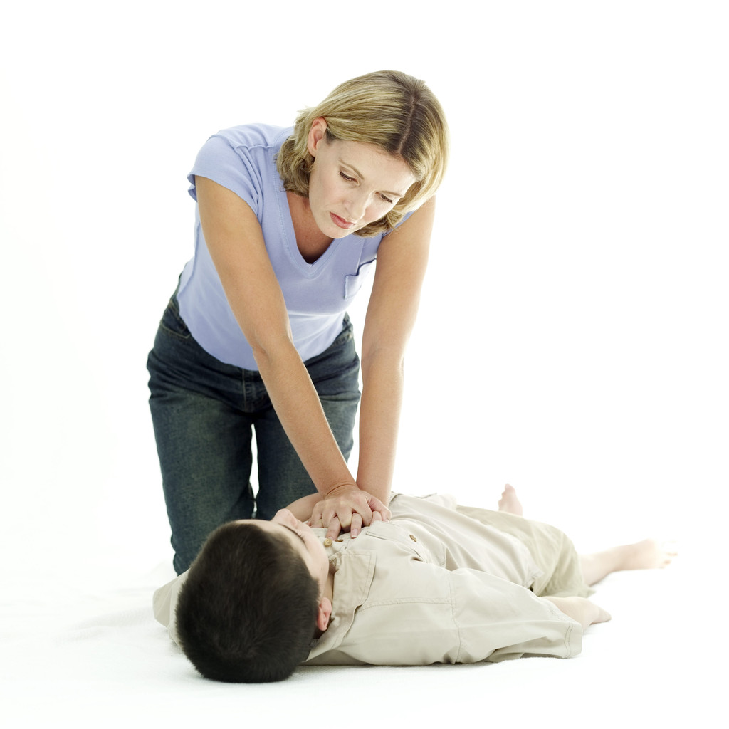
The first and last rule of first aid is "Do no further harm." That means you need to know what you should not do as well as what you should do. Here are some important don'ts:
- Don't give fluids to an unconscious person.
- Don't move the victim unless necessary for the person's safety if you suspect back, neck, head injuries, or broken bones.
- Don't stop rescue breathing or CPR until the person begins breathing or emergency medical help arrives.
- Don't use a tourniquet to stop bleeding. Instead, apply pressure directly to the wound. If it's an arm or leg that's bleeding, elevate the limb above the heart and use pressure points on the inside of the upper arm or on the crease of the groin area.
- Don't wait to call 911 for serious injuries until you've applied first aid--call first.
- Don't break burn blisters, apply ointments to burns, or try to clean severe burns--just cover and get immediate medical attention.

