Picture of task/equipment: | Task: |  | Back of the House, Dining Services. Walking through kitchens
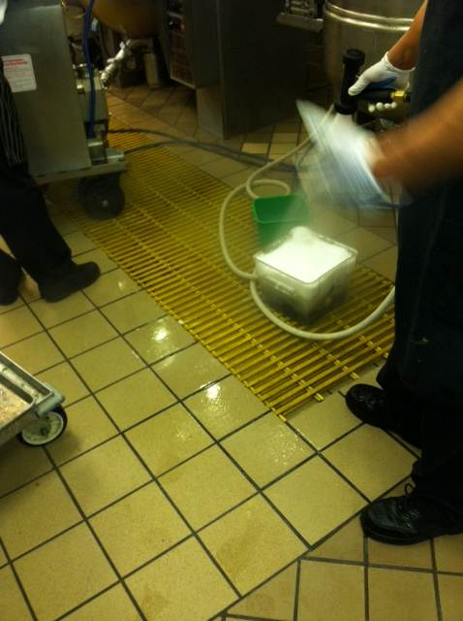 | Name of Shop or Dept: |  | Dining Services
 | Job Title(s): |  | All Dining Services staff
 | Analyzed by: |  | M. Williams
 | Date: |  | 2/8/13
Required PPE:
Non-slip shoes
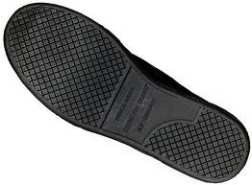

Required/Recommended Trainings:
Slips, trips & Falls (STF)
TASK | HAZARDS | CONTROLS
Walking through Wet Kitchens  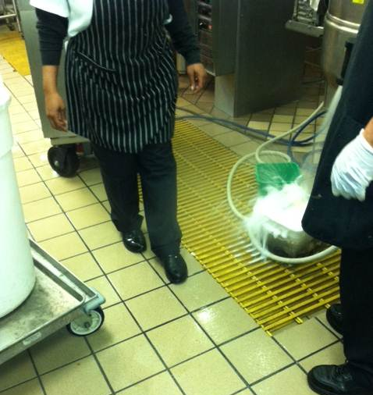  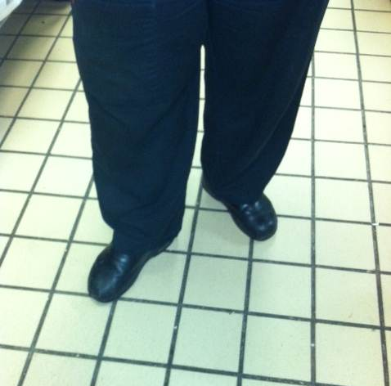 | Slips  Falls | - Always be aware of your surroundings when walking through busy environments such as kitchens.  - Don non-slip shoes such as Shoes for Crews before entering a wet area.  - Look for hazards such as carts, buckets, boxes and wet floors. Anticipate movement to avoid slips or falls.  - Avoid carrying items that block vision, instead use carts as it also provides support.  - Call out your location when rounding corners to make others aware and minimize sudden stops or movements.  - Place wet floor signs around puddles to warn others of hazards.  - If you have to leave slip resistant shoes in a locker, make sure to walk with toes out (duck walk) as you exit to provide extra support; see photo.

 | Injury & Illness Prevention Program  Job Safety Analysis Form

