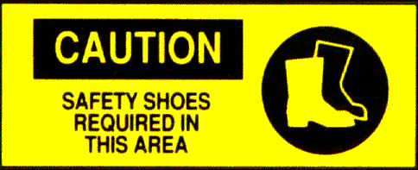
Foot Safety (Part 2)

OSHA says make them wear the right protection for the job. The regulations (Section 1910.136) require foot protection when there is a danger of foot injuries. Depending on the specific hazards, employees may need to wear special foot protection such as:
- Rubber or wooden-soled shoes for wet or slippery surfaces
- Reinforced impact-resistant work shoes or boots to protect feet and toes from being bruised or crushed
- Rubber or neoprene boots to protect against chemical hazards
- Metal insoles or reinforced soles to protect against punctures
- Non-conducting shoes, with no metal or nails, for working around electricity

Foot-safe footwear prevents the agony of the feet. Even when special protective footwear isn't needed, work shoes or boots should:
- Fit comfortably, without slipping or pinching the foot or toes.
- Be solidly constructed of sturdy materials that can resist wear and tear.
- Provide good foot support.
- Have low heels and nonskid soles for good traction.
- Be in good condition, with no rips or holes.
- Fasten securely; laces shouldn't drag on the floor.

Put your best foot forward to prevent foot injuries. Take the time to learn these general foot safety rules and teach your fellow employees as well:
- Identify foot hazards for your job and select the proper foot protection.
- Always wear appropriate foot protection whenever there is a risk of foot injury.
- Keep alert to foot hazards and avoid careless or risky behavior that could result in a foot injury.
- Watch where you're going and walk, don't run, from place to place.
- Always pay attention to where you place both your feet.

