Picture of task/equipment: | Task: |  | Glass Cleaner
 | Name of Shop or Dept:
 | Job Title(s):
 | Analyzed by:
 | Date:
Required PPE:
- Safety Glasses
- Rubber Gloves

Required/Recommended Trainings:
- Personal Protective Equipment

TASK | HAZARDS | CONTROLS
1.Prepare work area | N/A | N/A
2. Get class cleaner and paper towels | N/A | N/A
3. Spray glass at safe distance | Eye or face contact with hazardous chemical  Spraying with the mist option increases likelihood of getting chemical in the eyes | Safety glasses  Check equipment before beginning job
4. Wipe side to side or up and down until the glass is dry. | Cuts or snags on glass | Rubber gloves  Avoid cleaning any broken or bumpy glass.

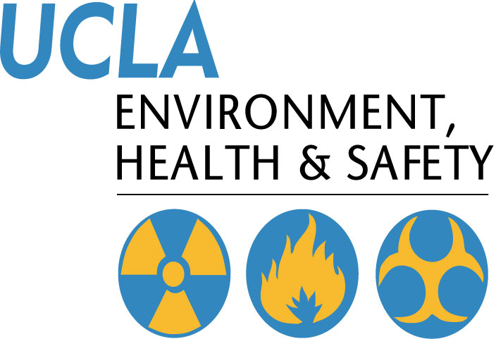 | Injury & Illness Prevention Program  Job Safety Analysis Form

