Hard Hats – Not Just for Decoration
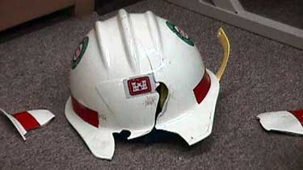
Head injuries are fairly common in industry and account for 3 – 6 % of all industrial injuries. They are often severe and result in an average lost time of about three weeks. Prevention of head injuries is an important factor in safety. A single injury can handicap an employee for life, or it can be fatal. Injuries to the head are very serious so use your Head and wear your hard hat. It may just save your life.

How Hard Hats Protect You
A Hard Hat provides the following features for your protection:
- A rigid shell that resists and deflects blows to the head.
- A suspension system inside the hat that acts as a shock absorber.
- Some hats serve as an insulator against electrical shocks.
- Shields your scalp, face, neck and shoulders against splashes, spills and drips.
- Some can be modified so you can add face shields, goggles, hoods or hearing protection to them.

Inspect your hard hat before and after each use. Although there is not a set service life for hard hats, manufacturers recommend replacement after no more than 5 years.

When to Replace Your Hard Hat
- Cracks appear in the shell
- Shiny surface appears dull or chalky
- Shell becomes brittle

Replace your Suspension When:
- The suspensions become brittle
- One or more of the mounts break off
- The suspension will no longer hold securely to the head
- The cradling straps break or become worn.

The hard hat with or without logos can be cleaned with simple soap and water or by using a damp towel.

Need a Hard Hat for your project? See your HSE Representative today; don’t wait until it is to late.

