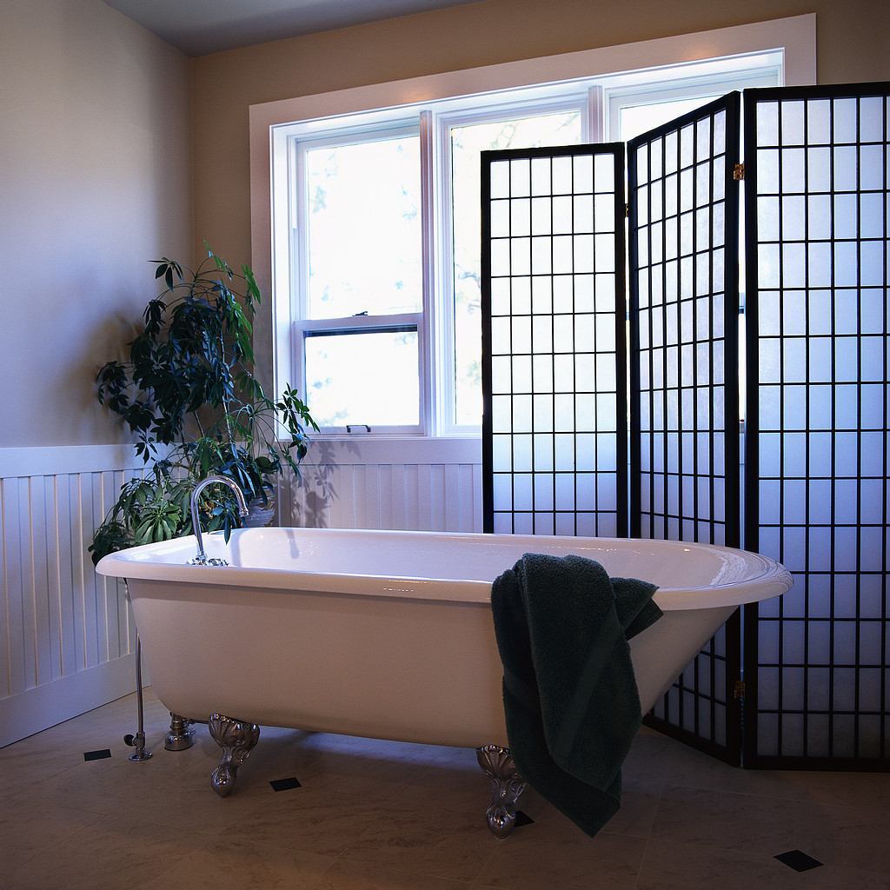
Home Danger Zones - Part 2

The bathroom: Water hazards

It's no joke - children really can drown in a couple of inches of water. Wolfson, of the product safety commission, puts it simply: "Never leave young children alone near any amount of water."

"Always keep a baby within arm's reach in a bathtub," he says. "Never leave to answer the phone, answer the door, get a towel or for any other reason. If you must leave, take the baby with you." Also it can be a fatal mistake to leave another child in charge. Use clips to keep toilet seats down or at least keep the lid closed so babies stay out.

Falls are another bathroom hazard. More than three-quarters of the injuries among those 75 and older are from falls, in bathrooms and elsewhere. Babies and elderly people fall from toilets and in slick tubs and showers. That's why safety experts like grab bars and slip-resistant surfaces installed in bathrooms to help everyone get a grip.

Poison is the leading cause of home injury. (Thankfully, the vast majority don't prove fatal.) Every seven minutes, a child arrives at an emergency room with a suspected poisoning, yet it's all preventable. The mini-pharmacies in medicine cabinets and the arsenal of toilet cleaners, cleansers and drain chemicals in bathroom cupboards are a magnet to curious youngsters. Even baby oil and mouthwash containing ethanol are potentially poisonous.

Experts tell parents to lock medicine cabinets and cupboards and use childproof containers for medicines. But careful parents have already done that: Some 30 children die yearly from ingesting household products - far fewer than the roughly 450 who died each year in the 1960s. Yet, there's one source of poison that escapes many vigilant parents: Visitors with medications in non-childproof containers. "It's often grand mom visiting, with her medications" who is the source of an accidental poisoning, says McKay, an emergency room physician.

