Home Danger Zones - Part 4

Stairs and ladders: Staying upright

Falls are scary for everyone, but for older people, a bad fall can spell the end of independence. "If you make the house safe for seniors, you're making the house safe for everybody," says Salvatore.

Fatal falls happen most often from stairs, according to the Consumer Product Safety Council (falls from beds rate second, and from ladders, third). The lessons are: Keep stairs completely clear of any obstacles; get baskets to carry things up and down the flight and use them.

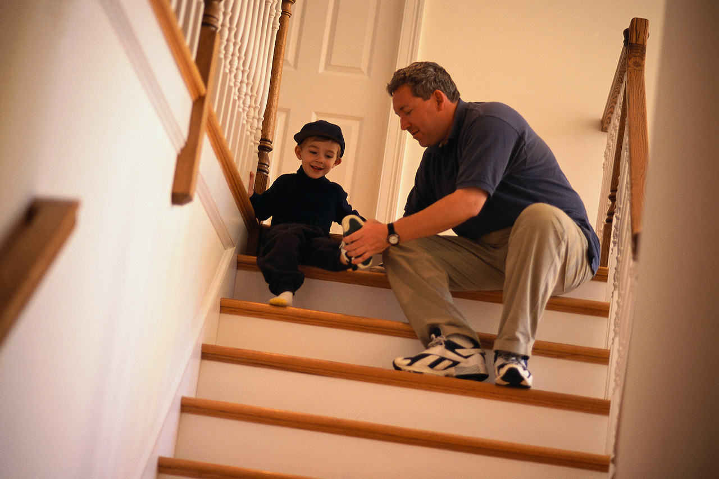
Don't climb a ladder heedlessly. Get help stabilizing it first. And put phones and emergency numbers where they're accessible for getting help if you fall.

