Home Danger Zones - Part 5

Pools and hot tubs: An attractive nuisance

Each year, about 250 children under 5 drown in pools and more than 100 drown in bathtubs, spas or buckets of water. Don't leave even a tiny bit of liquid lying around, says Wolfson of the product safety commission. Store buckets upside down and out of reach. If you've got a pool, learn CPR.

Backyard swimming pools are what insurance expert Salvatore calls "an attractive nuisance." Not only must you watch your own children carefully, you also have to figure out how to keep neighborhood kids from taking a dangerous, uninvited plunge.

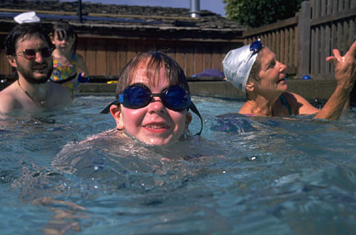
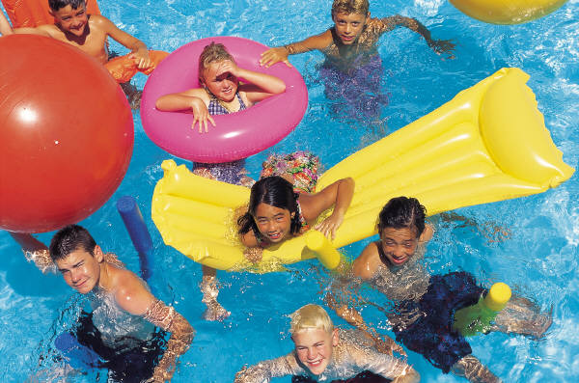
It's an awesome responsibility, being a parent and keeping a safe, cozy home for your family. Fortunately, once you've done the prevention and educated everyone around you, you can relax; knowing that you've made your house a safer place for loved ones.

