How to Use a Portable Fire Extinguisher
Do you know how to extinguish a fire? According to OSHA regulations, no one at a workplace is supposed to use a fire extinguisher unless they have been trained to do so. Though this may seem awfully restrictive, there are several good reasons for this rule. If an untrained person tries to extinguish a blaze, some serious mistakes can happen. Any of these mistakes can cause the fire to become worse, or injure or kill the individual.

There are four things to remember when it comes to using a fire extinguisher: Use Your Judgment, Communicate, Ready the Extinguisher, and Use It. You must also know what to do if your efforts fail.
Use Your Judgment --When you see smoke or fire you should use your own good judgment before you decide to extinguish the blaze. Ask yourself these questions:
• Is the fire limited in size and spread?
• Will you have an escape route if something goes wrong?
• Do you know the location of the nearest fire extinguisher?
If you are confident the fire is controllable and your safety is ensured, attempt to put it out. If the answer to any of these questions is no, evacuate the area immediately.
Communicate -- Once you have decided to extinguish the blaze, make every reasonable attempt to tell at least one other person what you are doing. This person should report your activity to someone else as soon as possible.
Ready the Extinguisher --You must select the proper extinguisher. Fire extinguishers are classified according to the type of fires they extinguish. It is very important to use the proper extinguisher. Some extinguishers are rated for more than one class. Some are for only one type of fire. Just be sure the extinguisher you're using is rated for the fire you're extinguishing.
Class A Use on ordinary combustibles such as wood, cloth, paper, rubber, and many plastics.
Class B Use on flammable liquids such as gasoline, oil, grease, tar, oil-based paint, lacquer, and flammable paint.
Class C Use on energized electrical equipment including wiring, fuse boxes, circuit breakers, machinery, and appliances.
Class D Use on flammable solids such as magnesium.
Ready the Extinguisher --
• Quickly but carefully remove the extinguisher from its mounting bracket. It may be heavy, so use caution when lifting it.
• Stand about six feet from the fire.
• Extend the nozzle toward the fire.
Use It --Once the extinguisher is ready, you are ready to release the extinguishing agent. This must be done properly. For example, if you squeeze the handle before you have aimed the nozzle properly; valuable time and extinguishing agent will be wasted.
A technique to remember for using an extinguisher is published by the National Fire Protection Association (NFPA). It is known as the P.A.S.S. Technique.
The P.A.S.S. Technique:
Pull out the pin that secures the handle. | 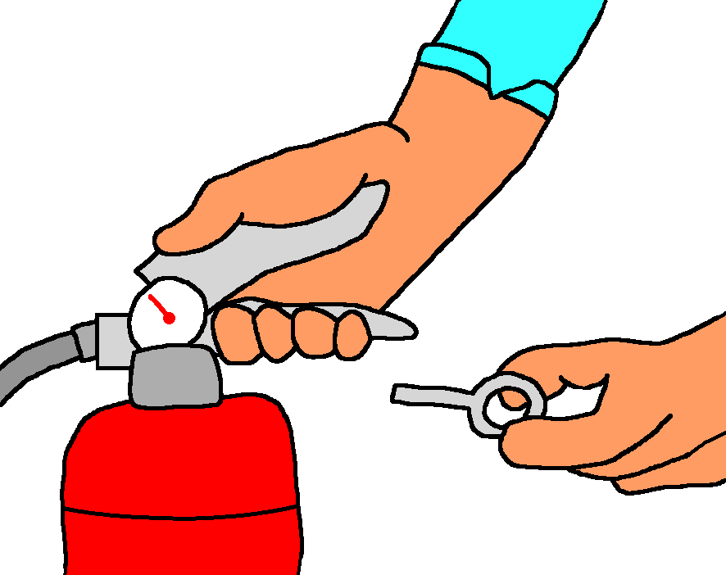
Aim the extinguisher nozzle at the base of the fire. |   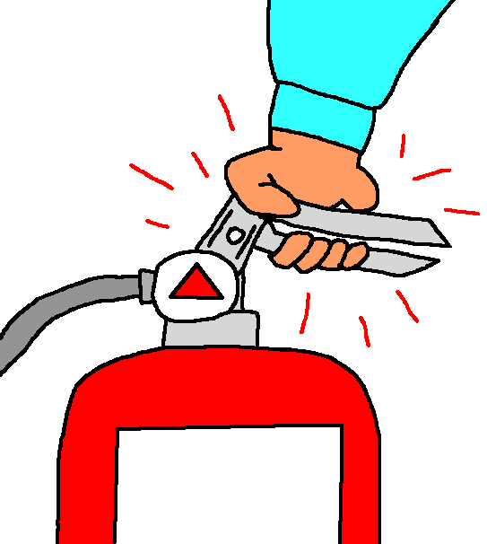
Squeeze the handle. (Do not be startled by the noise or velocity of the agent as it is released.)
Sweep the agent stream from side to side across the base of the fire until it is completely out. Be alert for re-ignition. If this happens, douse the fire until the extinguisher is empty. | 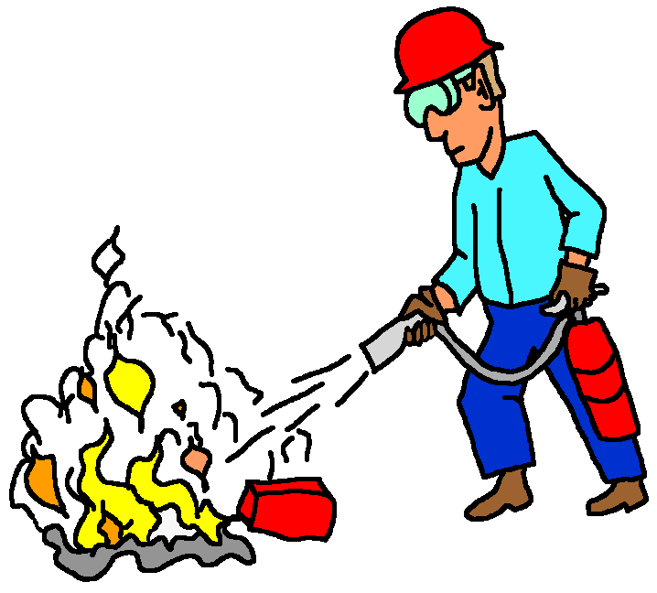
Once the fire is out, carefully back away from the scene. This will enable you to know immediately if the fire re-ignites.
Knowing how to use a fire extinguisher the right way is an important skill. Sometimes, though, in spite of your best efforts, your attempt may fail. The last point to remember about using a fire extinguisher is what to do if your efforts fail. It is really quite simple. If you cannot extinguish the blaze or it recurs repeatedly, evacuate the area immediately.
The best time to familiarize yourself with potential fire hazards and where fire extinguishers are located in your work area is before a fire happens. Knowing the hazards that exist, and what types of fires could occur are critical skills to working safely. You can also use this knowledge to make sure the proper type of fire extinguisher is available nearby should the need arise.

