Inspections by Regulatory Agencies

Here are some simple steps to follow in the event you too are surprised by a regulatory agency:

Obtain Positive Identification – Request the inspector provide you with formal identification (photo identification card). Call the agency if there is any question regarding the identity of the individual (independently obtain the agency's number; don't use a number provided by the representative). Also, obtain a business card from the inspector for URS records.
Do Not Request a Warrant – Do not require the inspector to obtain a warrant prior to conducting the inspection.
Notify – Contact the local URS Health, Safety, and Environment (HSE) Representative and/or URS Regional HSE Manager immediately upon confirming the identification of the representative. If the representative is from an Environmental/Public Health agency, also contact the local environmental group leader and Office Manager.
Request an Opening Conference – Even if one is not initiated by the inspector, request one be held. Use the opening conference to determine why the inspector is conducting the inspection. And remember to take good notes during the conference.
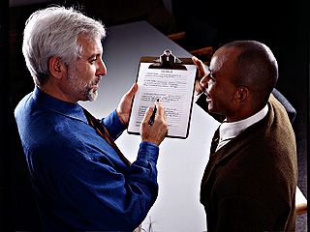
Escort the Inspector – Escort the inspector at all times, taking them directly to the area of interest. Answer all questions honestly, but do not volunteer information. Do not argue with or attempt to mislead the inspector. Resolve and correct conditions while the representative is on site, if possible. Take good notes during the inspection and take pictures where the inspector takes pictures. Inspectors generally have the right to interview employees if they do not interrupt operations.
Hazardous or Restricted Areas – Make sure the inspector has appropriate qualifications to enter high hazard areas.

Request a Closing Conference – Just like the opening conference, request a closing conference even if one is not initiated by the inspector. Use the closing conference to determine what regulatory violations the representative found, if any. Do not try to negotiate during the closing conference. Again, take good notes during the conference.

Once the inspection is completed you are required to follow the following steps:

Immediately Contact the Regional HSE Manager – Communicate the results of the inspection with the URS Regional HSE Manager and they will provide additional instructions regarding the inspection, if needed.
Debrief Employees – Employees who were contacted by the representative should be debriefed and all discussions should be turned into written notes.
Follow-Up Activities – All follow-up activities associated with the inspection will be coordinated by the Regional HSE manager, the Vice-President of HSE and appropriate Legal Counsel.

