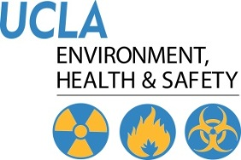 | Injury & Illness Prevention Program  Job Safety Analysis Form
501 Westwood Plaza, 4th Floor • Los Angeles, CA 90095
Phone: 310-825-5689 • Fax: 310-825-7076 • www.ehs.ucla.edu

Picture of task/equipment: | Task: |  | Equipment cleaning
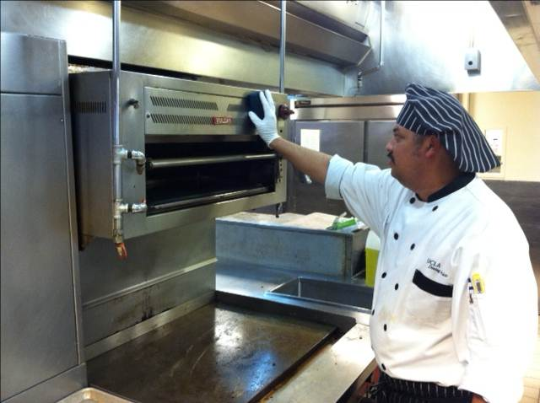 | Name of  Shop or Dept: |  | Dining Services
 | Job Title(s): |  | FSW, SFSW, Asst. Cook
 | Analyzed by: |  | M. Williams
 | Date: |  | 02/20/13
Required PPE:
Non-slip shoes Disposable nitrile gloves
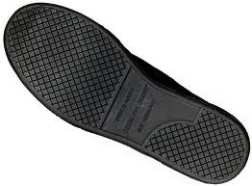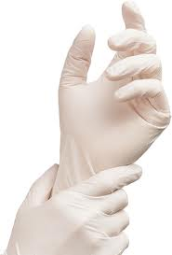
Required/Recommended Trainings:
STF safety
TASK | HAZARDS | CONTROLS
Daily cleaning of kitchen equipment  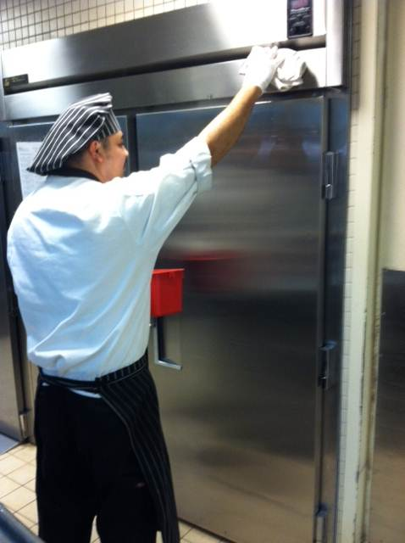  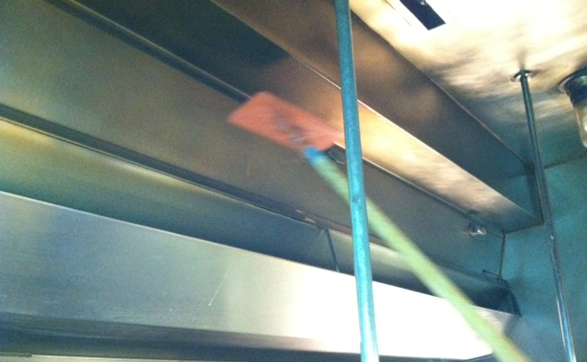 | Slips  Trips  Skin irritation | - Note; if using chemicals to clean please refer to either the JSA for the specific piece of equipment and/or the mixing chemicals JSA.  - Don disposable gloves to prevent skin contact with soapy water and/or dirty equipment.  - Don non-slip shoes to prevent slips from wet floors.  - Always use a “tower” to premix soap with water, never attempt to mix by hand.  - Avoid using a spray system to clean equipment as this can aerosolize and make contact with eyes, nose or mouth.  - Using a clean rag or scratch less pad, clean all equipment top down by dipping into a soapy bucket, keeping hand/arm position in front of body.  - In the event you can’t reach an area use a tool such as a 3M doodlebug to clean out of reach places. Avoid using a ladder unless absolutely necessary.  - Never stand on equipment to clean out of reach places as the equipment could be damaged and/or is not intended for this load.  - If spills occur while cleaning, place a wet floor sign in the direct area to notify other TM’s. Clean up spill; refer to mopping JSA.

