LABELS
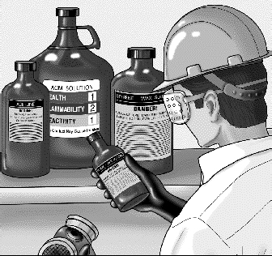
Chemical container labels must include the following information:
- The identity of the chemical - what it is (remember, there may be more than one kind of chemical in the container)
- The name, address, and phone number of the manufacturer or importer
- The physical hazards of the chemical - what it might do if handled improperly (such as catch fire or explode)
- The health hazards of the chemical - how it might hurt you

Labels also may include some or all of the following information:
- Instructions for proper storage and handling - how to avoid accidents and physical hazards
- Basic protective measures - such as personal protective equipment and procedures for safe use
- Labels may also include emergency instructions - what to do if something goes wrong

ALWAYS READ THE LABEL
BEFORE USING THE CHEMICAL -
YOUR HEALTH AND SAFETY DEPEND ON IT!

Do’s and Don’ts of Using Chemical Labels

DO:
- Read the label before starting to work with the chemical
- Follow the warning instructions on the label
- Understand the color - and number-coding system on labels in your workplace
- Read and follow label guidelines for consumer products (such as cleaners and pesticides)
- Report containers with missing, covered, or illegible labels to a supervisor
- Put labels on portable containers for hazardous chemicals
- Consult the MSDS as well as the label for complete information about the chemical

DON’T:
- Use any container that doesn’t have a label, or if you can’t read the label
- Ignore safety warnings on the label
- Work with a chemical if you don’t understand the information on the label

