 | Injury & Illness Prevention Program  Job Safety Analysis Form

Picture of task/equipment: | Task: |  | Municipal trash
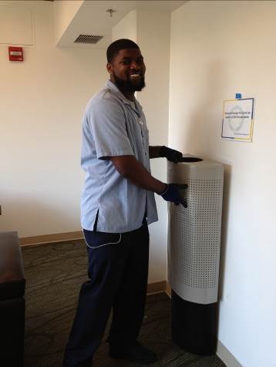 | Name of  Shop or Dept: |  | OCH-Rooms
 | Job Title(s): |  | Custodian, Assistant & Senior
 | Analyzed by: |  | M. Williams
 | Date: |  | 05/09/13
Required PPE:
Non-Slip shoes Neoprene (thick) gloves
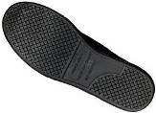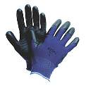
Required/Recommended Trainings:
STF Safety Ergonomics
TASK | HAZARDS | CONTROLS
Manual trash handling  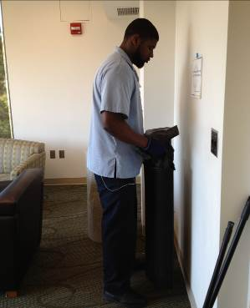  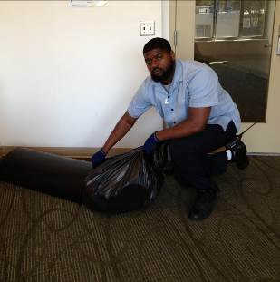 | Lacerations  Punctures  Slips  Trips  Falls  Sprains  Strains | - Don PPE, including non-slip shoes and gloves prior to handling trash.  - Visually look over the contents of the trash to make sure nothing is protruding from the can that can cause injury  - Check the weight of the trash can by tilting or tapping it, if the bag is too heavy avoid lifting straight up.  - For heavy loads tilt the trash can down to eliminate the need to pull trash vertically.  - Use proper lifting techniques. Bend your knees, keep close to the waste can and keep your back straight as you pick up or lower trash cans.  - Remain upright while relining the trash cans, avoid bending at the back.  - Whenever possible, use both hands to pick up and lower trash cans.  - For small office trash cans one hand can be used, but alternate hands whenever possible, especially when emptying a high frequency of offices.  - Never manually push the trash down with your hands as there may be sharp objects.  - Remember to think before you lift and focus on the specific task.

