 | Injury & Illness Prevention Program  Job Safety Analysis Form

Picture of task/equipment: | Task: |  | Mopping hard floors (Tile/Wood)
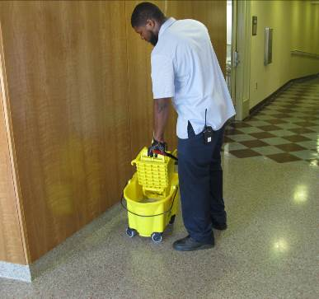 | Name of  Shop or Dept: |  | OCH-Rooms
 | Job Title(s): |  | Custodian, Asst & Senior.
 | Analyzed by: |  | M. Williams
 | Date: |  | 05/14/13
Required PPE:
Non Slip Shoes Gloves

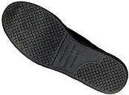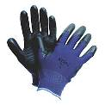
Required/Recommended Trainings:
STF Safety Hazard Communications Ergonomics
TASK | HAZARDS | CONTROLS
Mopping Hard floors  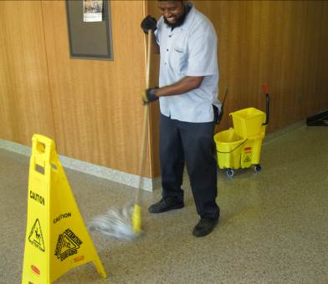 | Slips  Falls  Sprains  Strains  Chemical exposure | - Don PPE, including non-slip shoes and gloves.  - If there is risk of splashing, spraying or spattering (e.g. when pouring/mixing chemicals into mop bucket), wear a face shield.  - Never attempt to mix concentrated chemicals by hand, instead use a waxie/diversy mixing station.  - Place wet floor signs in the area to inform others of slip hazard.  - Check floor to ensure it is free of debris prior to mopping.  - Mop side to side using both hands in a sweeping motion.  - Use neutral postures, keeping mop in front of you, and avoid twisting side to side.  - Mop with wet mop head in front of you, slowly moving backwards to limit standing on wet surfaces.  - Avoid overreaching or “wide” mopping; maintain mopping activities in front of body.  - Switch right and left hand position often to avoid strain from overuse.  - When ringing out mop head, avoid bending back bend with knees instead.  - Keep wet floor sign posted until floor is fully dry.

