Picture of task/equipment: |  | Task: | Operating a Drain Cleaner – Gasoline Powered Jetter
 |  | Name of Shop or Dept:
 |  | Job Title(s):
 |  | Analyzed by:
 |  | Date:
Required PPE:
1. Dust Mask
2. Face Shield, Glasses or Goggles
3. Gloves Rubber/Latex

Required/Recommended Trainings:
1. User Must Read Owners manual
2. User Must Train with Supervisor
TASK | HAZARDS |  | CONTROLS
1. Inspect Jetter Sweeper before each use  2. Must only be used out of doors | 1. Eye Injury From Particles  2. Bodily injury from accidental contact with extremely high pressure water stream.  3. Burn from exhaust muffler of gasoline engine.  4. Skin irritation from Chemicals that may be in waste line.  5. Bio-Hazard from contact with Human Waste |  | 1. Equipment to be Inspected after each use  2. Equipment to be Serviced bi-annually by factory representative.

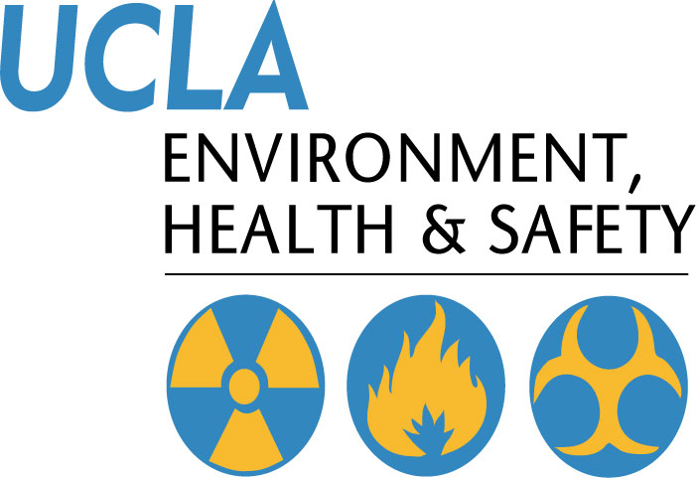 | Injury & Illness Prevention Program  Job Safety Analysis Form
501 Westwood Plaza, 4th Floor • Los Angeles, CA 90095
Phone: 310-825-5689 • Fax: 310-825-7076 • www.ehs.ucla.edu

