Permissible Exposure Limits
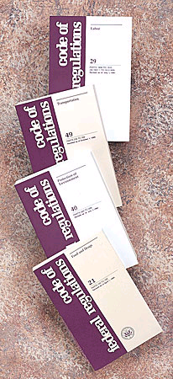
OSHA has set enforceable permissible exposure limits (PELs) to protect workers against the health effects of exposure to airborne hazardous substances. These PELs are regulatory limits on the amount or concentration of a substance in the air. Typically PELs are thought of as a regulatory standard for the amount that is considered safe to breath, however some PELs may also contain a skin designation for dermal exposure.

OSHA PELs are based on an 8-hour time weighted average (TWA) exposure. This is the amount an individual can be exposed to over an average 8-hour period. However if an individual is working a 10-hour shift the actual concentration the individual can be exposed to drops.

Permissible exposure limits (PELs) are addressed in specific standards for the general industry, shipyard employment, and the construction industry. Section 5(a)(1) of the Occupational Safety & Health Act (OSH Act), often referred to as the General Duty Clause, requires employers to "furnish to each of his employees employment and a place of employment which are free from recognized hazards that are causing or are likely to cause death or serious physical harm to his employees". Section 5(a)(2) requires employers to "comply with occupational safety and health standards promulgated under this Act".

Note: Twenty-four states, Puerto Rico and the Virgin Islands have OSHA Approved State Plans and have adopted their own standards and enforcement policies. For the most part, these States adopt standards that are identical to Federal OSHA. However, some States have adopted different standards applicable to this topic or may have different enforcement policies.

OSHA has established approximately 500 PELs for various chemicals and/or compounds. Many of the existing PELs are contained in 29 CFR 1910.1000, also known as the air contaminants standard. Here is a partial list of compounds:

- benzene
- beryllium and beryllium compounds
- cadmium – dust and fumes (see 29 CFR 1910.1027)
- carbon disulfide
- carbon tetrachloride
- chromic acid and chromates
- ethylene dibromide
- ethylene dichloride
- fluoride as dust
- formaldehyde (see 29 CFR 1910.1048)
- hexavalent chromium
- hydrogen fluoride
- hydrogen sulfide
- methylene chloride (see 29 CFR 1910.1052)
- mercury
- organo(alkyl)mercury
- styrene
- tetrachloroethylene
- toluene
- trichloroethylene

PELs have also been established for exposure to mineral dusts, which include silica (crystalline and amorphous), silicates, graphite, coal dusts, and inert or nuisance dusts.

How a specific airborne hazard is best controlled depends on the nature of the hazard and the process and possibility that workers will be exposed. Whenever possible, airborne hazards should be engineered out of a process. If it is not possible to reduce the hazard, appropriate administrative controls can be used, and as a last resort personal protective equipment must be used.

If you or one of your fellow employees may be exposed to an airborne hazard .

