Safe Lifting Techniques We All Should Know

Why It Matters …
- Back injuries affect millions each year and cost billions in medical bills, lost wages, and insurance claims.
- Improper lifting is a major cause of back injury, both on and off the job.
- Workers lose an average of 7 workdays a year because of back injuries.

Got a plan?
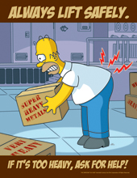
Using safe lifting techniques is essential for preventing sprains and strains. But there's more to safe lifting than just technique. Lifting really begins with planning the lift. This means that before lifting and carrying any object, you should examine the load and make sure:
- The weight is stable and won't shift.
- There are no rough spots or sharp edges (if there are, then you need a pair of thick gloves).
- You can handle it alone (if not, you should get help).
- You will be able to see over the load while carrying it (if, not you need to use material handling equipment or make a couple of trips on foot).
Workers also need to plan the route they'll take when carrying the load. This means:
- Mapping out the easiest route, not necessarily the shortest
- Moving objects to avoid bumping into or tripping over them
- Looking for safe places to stop and rest, if necessary
- Making sure the object can be unload easily and safely at the other end
Safe lifting is as simple as 1, 2, 3.
Once you have a plan, you are ready to proceed with the lift. To keep yourself safe while lifting, remember the anatomy of a lift. Here's how it works: When you lift, the backbone must support your weight as well as the weight of the object you're lifting. That puts extra strain on your spine, and if you're not careful, you could suffer a painful back injury. By using proper body mechanics, however, the muscles in the back, abdomen, buttocks, and thighs all work together to support the spine and prevent injury.
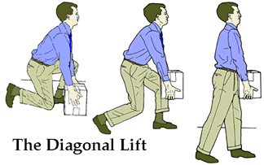
The secret to safe lifting is to:
- Assume the safe lifting position. Stand close to the object and keep a wide stance. Keep your feet turned out and your heels down. Then squat by bending at the hips and knees. Your ears, shoulders, and hips should form a nearly straight line.

- Prepare to lift. Pull the load close to your body (this reduces pressure on your back) and grasp the object firmly. Tighten your stomach muscles.

- Let the legs do the lifting. Maintain the natural curves of your spine and rise up from the squatting position using your legs to power the lift. Do not bend over at the neck, shoulders, or waist as you lift.
When it's time to unload, face the spot you've chosen and lower the load slowly--again by using your legs, not your back. Simply bend your knees and lower your body with the load, keeping your back comfortably straight.
Safe carrying spares the back and prevents tripping accidents, too.
Here are some important tips to ensure safe carrying:
- Make sure you can see over the load.
- Point your feet in the direction of your move.
- Take small steps to turn your body as a single unit--don't twist.
- Hug the load.
- Stop and rest if you need to.
- Walk at a steady pace and watch where you're going.

