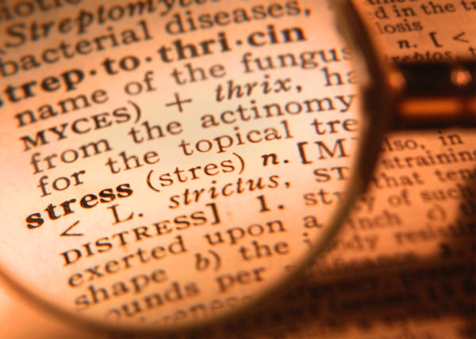
STRESS

It is a normal part of our daily lives. But it is how we react to and manage stress that affects the toll that stress will take on our lives. Overwhelming amounts of stress can lead to back pain, headaches, raised blood pressure, indigestion, sweating, palpitations, irritability and anxiety. It can also contribute to the development of such diseases as cold sores, ulcers and heart disease. Are you feeling stressed out?

Stress Management Techniques & Lifestyle Changes

Lifestyle Changes

Coping Skills – Try organizing your time differently, by getting more sleep at night or talking over your problems with a close friend or family member.

Dietary Changes – Eating foods that are good for you will help you stay focused, strong and healthy through the stress. Avoid coffee and caffeinated beverages that can add to the symptoms of stress.

Get Connected – Develop and strengthen your social network so that you will have people to turn to in time of stress. Consider a support group.

Take a Break – Learn to say NO. As much as you would like to, it is not possible for you to attend and assist with every project, event and activity. If you are stressed out, try to reduce your work or activity load a little, even try a vacation.

Exercise
Physical Exercises – help strengthen the body, relax the muscles and nervous system, integrate the mind and body, relieve muscle tension and improve physical function.

Mental Exercises – meditation helps you to clear your mind of stress and promote relaxation.

Relaxation Techniques

If you frequently become stressed, learn relaxation techniques that can help you manage stress throughout the day.

Breathing exercises – slow, diaphragmatic breathing and conscious muscle relaxation can help clear your mind and calm your physical responses to stress.

Herbs – there are many herbs that can be used to reduce stress and manage its symptoms. St. John’s wort, chamomile, ginger, wild yam, ginseng, borage, licorice, milk thistle and nettle have all been found to help in managing stress. Always consult a doctor before adding supplements to your diet.

Aromatherapy –Certain scents can calm the body and relieve the tension and anxiety that is often associated with stress. Essential oils of lavender, chamomile, geranium, rose, neroli, sweet marjoram, and ylang-ylang are commonly recommended for stress relief. These can be used in massage, added to a bath or inhaled through a vaporizer.

Employee Assistance Program

For professional assistance also has contracted with United Behavioral Health to provide information, resources and referrals to help improve our lives at work and at home, the Employee Assistance Program, also know as EAP. This program offers:

Expert Counseling – Professional counselors who are available to provide an objective viewpoint and expert guidance.

Legal Assistance – Professional who will help with resolving a legal dispute, drafting a will, or help finding mediation services.

Financial Services – Free, unlimited phone consultations with credentialed financial counselors for assistance with budgeting, debt management, retirement planning and other financial concerns.

If you need additional information or have any questions regarding the assistance available to you to help manage stress, please contact your Office Human Resources (HR) Manager or Representative, or your Office HSE Representative.

