Tailgate Safety Meetings

Tailgate Safety Meetings are short 10 to 15 minute meetings that should occur daily on field projects. They are intended to keep crews and employees alert and aware of accident potentials, hazards and safe working procedures. Tailgate Safety Meetings have been proven to create safer work environments and to also help prevent work related accidents.
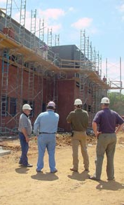
Why Tailgate Meetings

Tailgate safety meetings can be used to address actual problems encountered on the project, or lessons learned from other projects. The leader can draw on the experience of the workers to remind all employees, especially newer ones, the dangers of working with particular tools, machines, equipment and materials.

This is also an excellent time to get feed back from the employees regarding concerns or issues they have related to the work being performed. In fact, I would recommend that towards the end of the day the team meets for a short period to have another safety discussion about what they have done, seen, and encountered during their work. The helpers and newer employees should lead this meeting. These issues can then be addressed while they are still fresh in their minds, and also covered again the next day in the morning.

How to Run a Good Meeting
- Hold the meeting on the job
- Hold the meeting at the beginning of the shift right, after lunch, or after the last break of the day
- Choose the topic carefully. (should be topics that pertain to that job)
- Choose a specific topic that can be discussed in 15 minutes
- Encourage employee participation, yet keep meeting short.

What to Talk About
- Work Practices
- Machinery
- Tools
- Equipment
- Materials
- Attitudes
- Anything that may cause or contribute to a work related accident or illness

Benefits
- Increase in workers health, well-being and state of mind.
- Safer work environments
- Reduction in accidents
- Decreases in costs associated with accidents

If you have never led a tailgate meeting before and would like some assistance, please contact your Office HSE Representative or Regional HSE Manager.

