Injury & Illness Prevention Program
Job Safety Analysis Form

Picture of task/equipment: |  | Task: |  | General Vacuuming
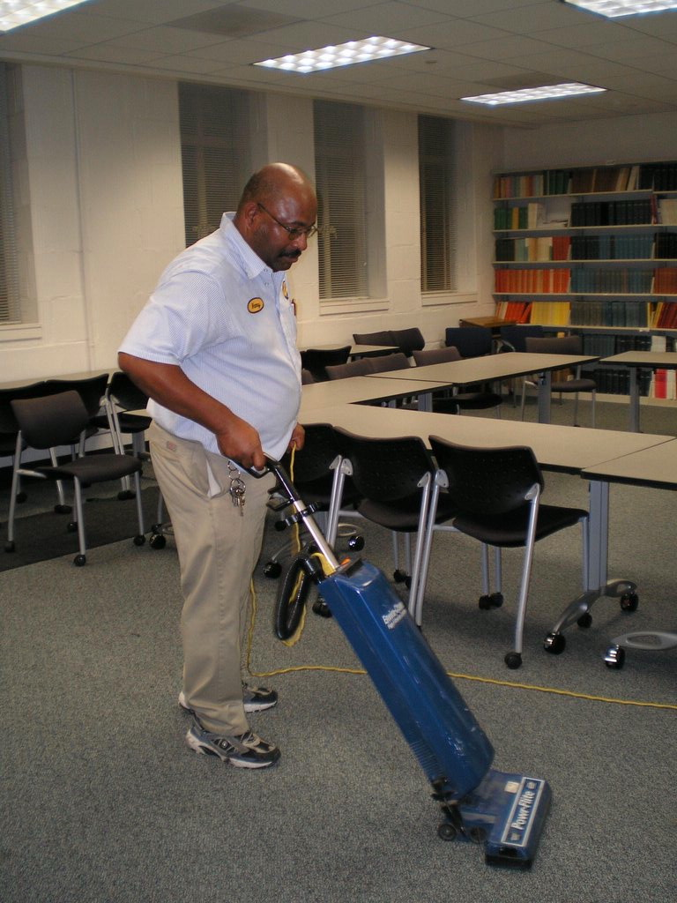 |  | Name of Shop or Dept:
 |  | Job Title(s):
 |  | Analyzed by:
 |  | Date:
Required PPE:
Cotton gloves
Required/Recommended Trainings:
First aid
PPE

TASK | HAZARDS |  | CONTROLS
- Check vacuum bag before using.  - Change bag when necessary.  - Vacuum under desks, tables and behind doors.  - Remove all furniture and other items interfering with the operation. | - Tripping hazard  - Back strain  - Electrical shock  - Bumps / bruises (from navigating around furniture) |  | - Maintain neutral position / postures for wrists, arms and shoulders  - Never position equipment so that it becomes a tripping hazard.  - Always unplug vacuum when changing bags or inspecting filter brush.  - Check cords daily for frays or breaks.  - Always roll chord on vacuum when not in use.

