 | Injury & Illness Prevention Program  Job Safety Analysis Form

Picture of task/equipment: | Task: |  | Walk behind push mower
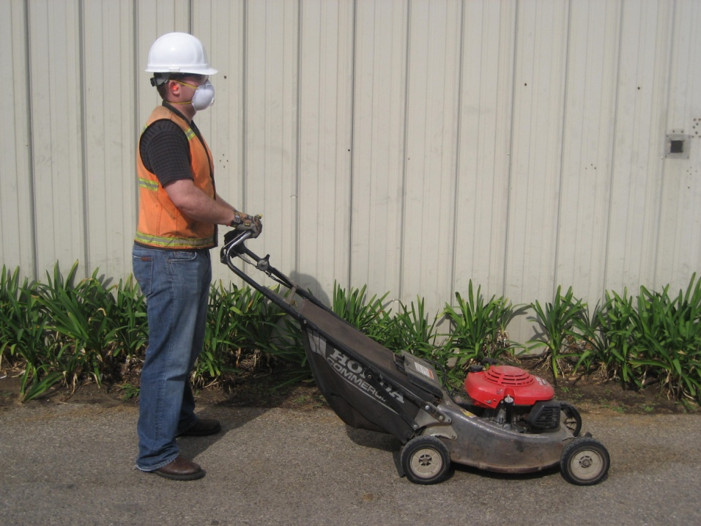 | Name of  Shop or Dept: |  | OCH-Grounds, LACC & UA
 | Job Title(s): |  | Groundskeepers, Maintenance staff
 | Analyzed by: |  | M. Williams
 | Date: |  | 03/08/13
Required PPE:
Work boots Gloves hearing protection safety glasses dust mask Safety vest
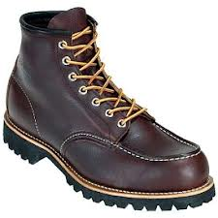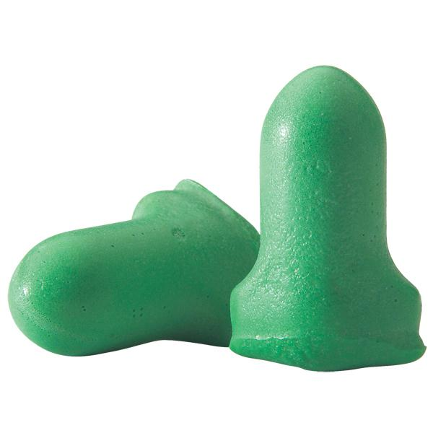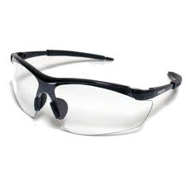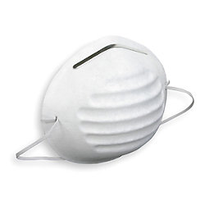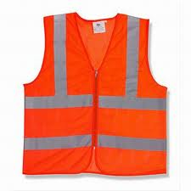
Required/Recommended Trainings:
STF Safety Equipment safety precautions
TASK | HAZARDS | CONTROLS
Operating a push mower  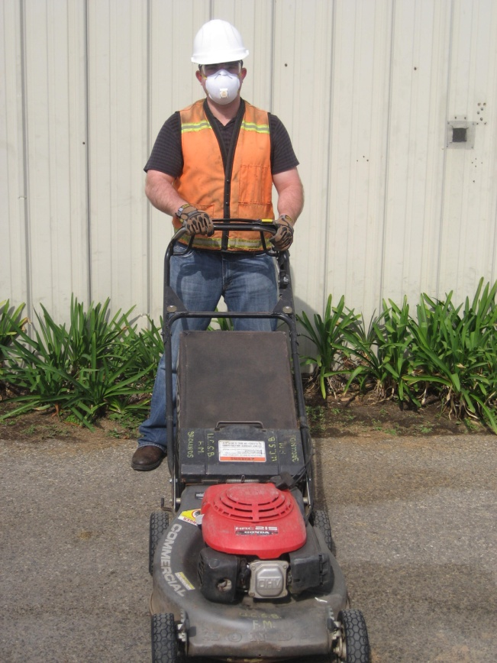 | Slips  Trips  Falls  Lacerations  Amputations  Struck-by’s  Burns  Hearing loss | - Don PPE before starting equipment, including non-slip work boots, Gloves, Hearing Protection, Safety glasses, a mask and a safety vest (when working near public roadways).  - Make sure all guards and collection bag are in place before operating equipment.  - Gas vapors are extremely flammable, only refill tank outdoors, in well ventilated areas. Make sure engine is off when refilling.  - Inspect area to be mowed for debris, such as sticks, wires, sprinkler heads, rocks, etc. Remove all debris prior to starting mower.  - Always keep clear of rotating blades. Blades will cut and can amputate fingers, hands, toes or feet.  - Never reach in or under mower while it is in the “on” position.  - When mowing on inclines, move across not up and down slopes.  - Watch for uneven surfaces, holes and slopes; take extra care with footing to avoid STF’s.  - Remember to look down and behind when it is necessary to walk backwards with the mower.  - Do not touch muffler while in operation. Muffler will become very hot and can cause burns.

