 | Injury & Illness Prevention Program  Job Safety Analysis Form

Picture of task/equipment: | Task: |  | Weed Trimmer
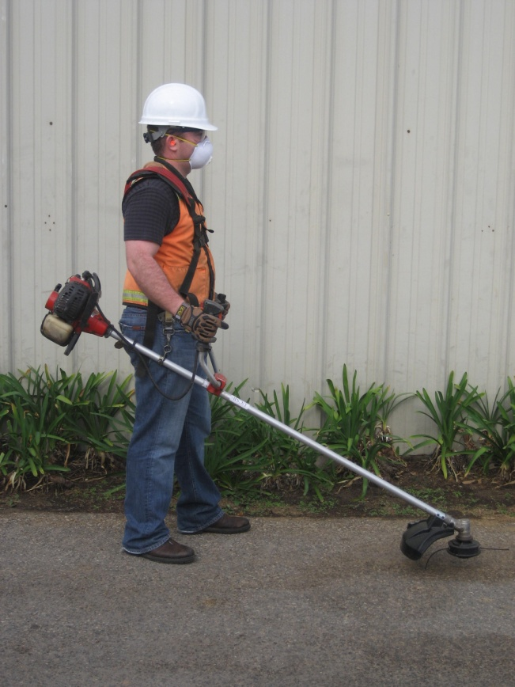 | Name of  Shop or Dept: |  | OCH-Grounds, UA & LACC
 | Job Title(s): |  | Groundskeepers
 | Analyzed by: |  | M. Williams
 | Date: |  | 03/07/13
Required PPE:
Work boots Gloves hearing protection safety glasses dust mask Safety vest
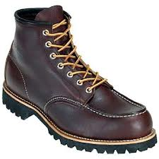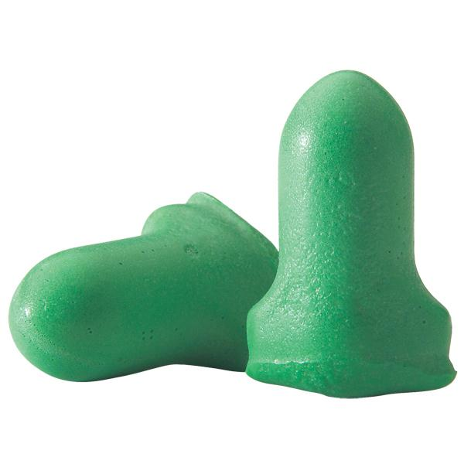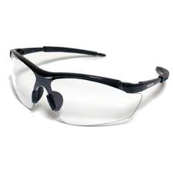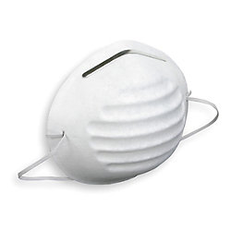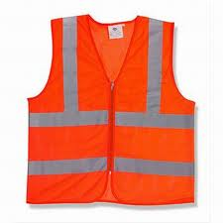
Required/Recommended Trainings:
STF Safety Equipment safety precautions
TASK | HAZARDS | CONTROLS
Operating a gas powered weed trimmer  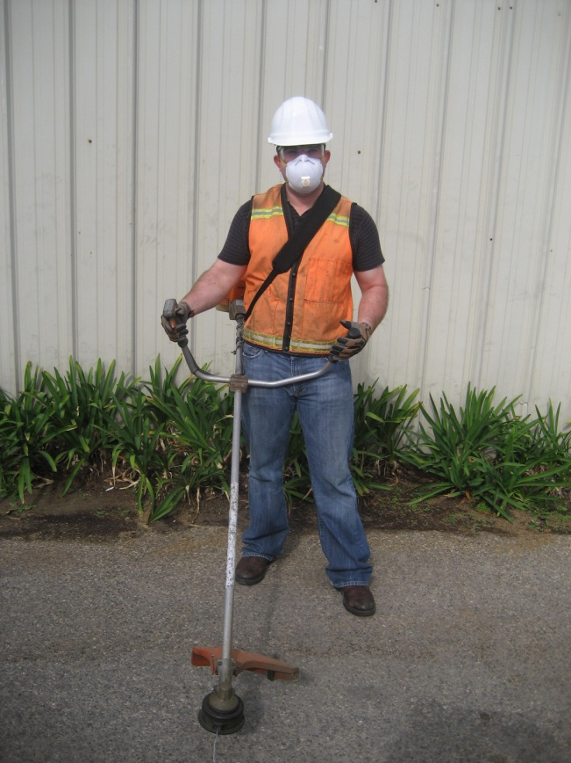 | Struck By’s  Lacerations  Slips  Trips  Falls  Vapor inhalation  Fire | - Don PPE before starting equipment, including non-slip work boots, Gloves, Hearing Protection, Safety glasses, a mask and a safety vest (when working near public roadways).  - Wear long pants, as flying debris can come in contact with lower limbs.  - Make sure all guards are in place before operating equipment.  - Inspect spark plug cap and lead to make sure they are not damaged, otherwise electric shock can occur.  - Do not operate within 50ft of persons or traffic as injury or ricochet can occur.  - Do not operate next to glass, such as windows.  - Watch for uneven surfaces, holes and slopes; take extra care with footing to avoid STF’s.  - Keep hands, arms and dry debris away from the muffler, it can result in burns or fires.  - Never start the equipment indoors as exhaust can create a harmful breathing atmosphere.  - Hold trimmer head just above ground and let the cord cut; never force the cutter into grass or weeds.  - Do not try to make adjustments to the cutting cord while the machine is on.  - Do not try to remove debris while the machine is in operation; make sure machine is off before clearing.

