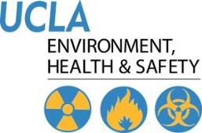 | Injury & Illness Prevention Program  Job Safety Analysis Form

Picture of task/equipment: | Task: |  | Cleaning
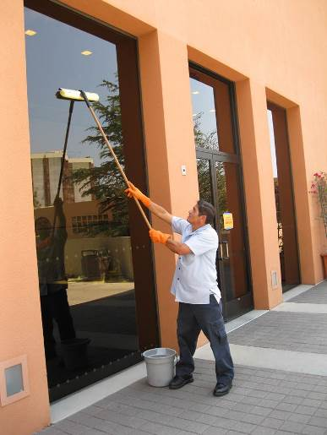 | Name of  Shop or Dept: |  | OCH-Rooms
 | Job Title(s): |  | Custodian, Senior & Assistant
 | Analyzed by: |  | M. Williams
 | Date: |  | 05/29/13
Required PPE:
Non-Slip Shoes |  |  |  |  | Work Gloves
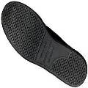 |  |  |  |  | 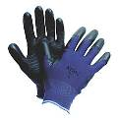

Required/Recommended Trainings:
STF Safety | Hazard Communication | Ergonomics

TASK | HAZARDS | CONTROLS
Window cleaning  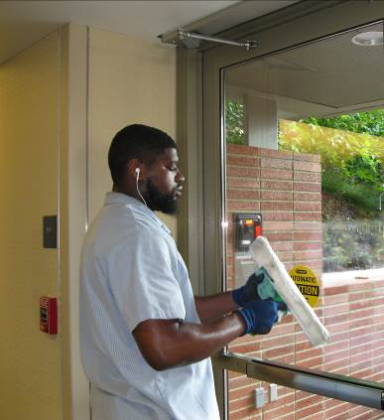 | Slips  Trips  Falls  Sprains  Strains | • Don non-slip shoes and work gloves prior to performing this operation.  • Prior to beginning work, look around and remove any large debris that may create a trip hazard.  • For smaller windows, store fronts, or doors use a sponge/squeegee and wet the sponge, sweeping across the window left to right and right to left.  • For tall windows use adjustable long handle to reach high areas, avoid using a ladder whenever possible.  • A padded nonslip handle can help with grip and fatigue.  • Alternate left and right hands at the top of handle to avoid static hand positions.  • Stand directly in front of the window you are cleaning, avoid twisting side to side as you wet and clean the windows.  • If water/soap create a wet floor, place proper signage to notify bystanders and other staff.

