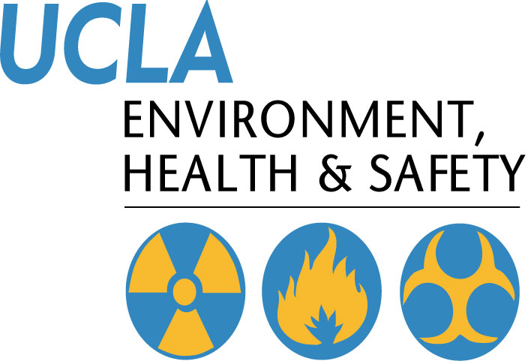 | Injury & Illness Prevention Program  Job Safety Analysis Form

Picture of task/equipment: |  | Task: |  | General Wiping/Washing
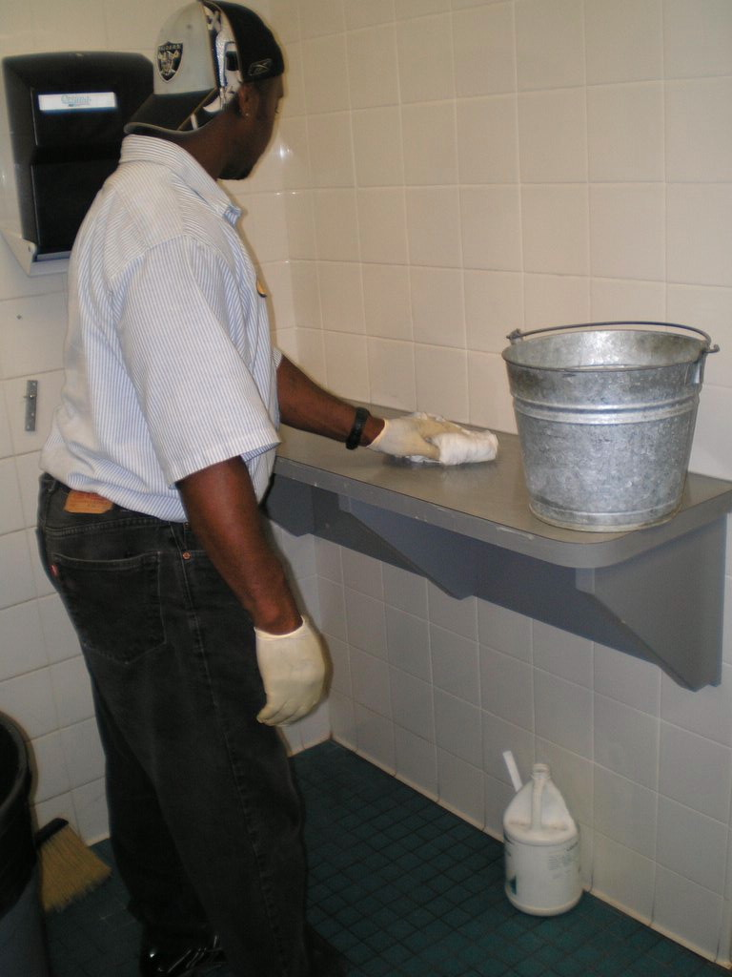 |  | Name of Shop or Dept:
 |  | Job Title(s):
 |  | Analyzed by:
 |  | Date:
Required PPE:
Disposable Gloves
Goggles (when spraying chemicals on rags or items to be cleaned)
Required/Recommended Trainings:
First Aid
PPE
TASK | HAZARDS |  | CONTROLS
- Spray all purpose cleaner directly on rag.  - Wipe surface to be cleaned  - Start wiping from top to bottom of item to be wiped / washed.  - Use damp rag with water only to rinse and dry out with clean rag. | - Chemical on skin / in eyes  - Reaching / bending |  | - Wear PPE (goggles / gloves)  - Maintain neutral position / postures as much as possible  - Switch hands and arms often  - Limit bending and kneeling  - Use long handles to reach high areas

