Working Outdoors in Warm Climates – Part II

The sun and heat aren't the only “culprits” that affect employees during the dog days of summer. Insects can be more than just a nuisance to those who work outside - some can cause serious illnesses including Lyme disease and West Nile Virus. Plants can also impact workers in the field. Here are just a few protective measures to help avoid the sting and bite so often inherent with outside work during the summer months.

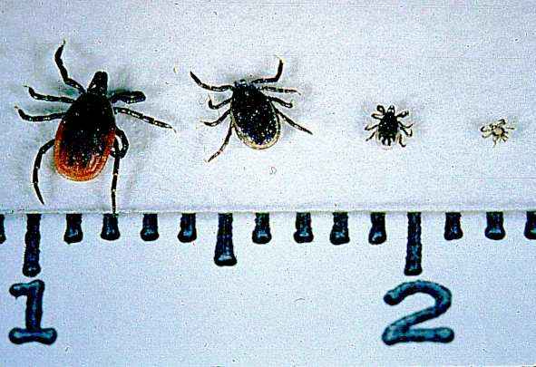
Lyme Disease/Tick-Borne Diseases
The deer tick adult female, adult male, nymph, and larva on a centimeter scale
These illnesses (i.e., Rocky Mountain spotted fever) are transmitted to people by bacteria from bites of infected deer (blacklegged) ticks. In the case of Lyme disease, most, but not all, victims will develop a “bulls-eye” rash. Other signs and symptoms may be non-specific and similar to flu-like symptoms such as fever, lymph node swelling, neck stiffness, generalized fatigue, headaches, migrating joint aches, or muscle aches. You are at increased risk if your work outdoors involves construction, landscaping, forestry, brush clearing, land surveying, farming, railroads, oil fields, utility lines, or park and wildlife management. Protect yourself with these precautions:
- Wear light-colored clothes to see ticks more easily.
- Wear long sleeves; tuck pant legs into socks or boots.
- Wear high boots or closed shoes that cover your feet completely.
- Wear a hat.
- Use tick repellants, but not on your face.
- Shower after work. Wash and dry your work clothes at high temperature.
- Examine your body for ticks after work.
Remove any attached ticks promptly and carefully with fine-tipped tweezers by gripping the tick. Do not use petroleum jelly, a hot match, or nail polish to remove the tick.

West Nile Virus
West Nile virus is transmitted by the bite of an infected mosquito. Mild symptoms include fever, headache, and body aches, occasionally with a skin rash on the trunk of the body and swollen lymph glands. Symptoms of severe infection include headache, high fever, neck stiffness, stupor, disorientation, coma, tremors, convulsions, muscle weakness, and paralysis.

You can protect yourself from mosquito bites in these ways:
- Apply Picaridin or insect repellent with DEET to exposed skin.
- Spray clothing with repellents containing DEET or permethrin. (Note: Do not spray permethrin directly onto exposed skin.)
- Wear long sleeves, long pants, and socks.
- Be extra vigilant at dusk and dawn when mosquitoes are most active.
- Get rid of sources of standing water (used tires, buckets) to reduce or eliminate mosquito breeding areas.

Poison Ivy-Related Plants
Poison ivy, poison oak and poison sumac have poisonous sap (urushiol) in their roots, stems, leaves and fruits. The urushiol may be deposited on the skin by direct contact with the plant or by contact with contaminated objects, such as clothing, shoes, tools, and animals.

Approximately 85 percent of the general population will develop an allergy if exposed to poison ivy, oak or sumac. Forestry workers and firefighters who battle forest fires have developed rashes or lung irritations from inhaling the smoke of burning plants.
- Wear long-sleeved shirts and long pants, tucked into boots. Wear cloth or leather gloves.
- Apply barrier creams to exposed skin.
- Educate workers on the identification of poison ivy, oak, and sumac plants.
- Educate workers on signs and symptoms of contact with poisonous ivy, oak, and sumac.
- Keep rubbing alcohol accessible. It removes the oily resin up to 30 minutes after exposure.

