Working at Heights
Purpose:
The Working at Heights Safety Standard is intended to protect workers from the hazards of working at heights and comply with Fall Protection Regulations.
Objective:
Following this Standard will reduce or eliminate injuries to workers from falls to another level.
Scope:
This standard applies to all employees and contractors working for the company.
Responsibility:
Management:
Management must ensure that a fall protection system is used when required.
Supervisors:
Supervisors will be familiar with all aspects of the Working at Heights Standard. Before workers are allowed into a location where a risk of falling exists, the supervisor and employee must discuss the appropriate fall protection plan for the job. The supervisor will ensure that employees are properly trained in the appropriate fall protection equipment and procedures.
Employees/Workers:
Employees are responsible for using the appropriate fall protection systems where work being done requires its use.
Regulation:
Fall Protection Regulation Obligation to use fall protection.
(1) Unless elsewhere provided for in this Regulation, an employer must ensure that a fall protection system is used when work is being done at a place
(a) from which a fall of 3 m (10 ft) or more may occur, or
(b) where a fall from a height of less than 3 m involves a risk of injury greater than the risk of injury from the impact on a flat surface.
(2) The employer must ensure that guardrails meeting the requirements of Part 4 (General Conditions) or other similar means of fall restraint are used when practicable.
(3) If subsection (2) is not practicable, the employer must ensure that another fall restraint system is used.
(4) If subsection (3) is not practicable, the employer must ensure that a fall arrest system is used.
(5) If the use of a fall arrest system is not practicable, or will result in a hazard greater than if the system was not used, the employer must ensure that work procedures are followed that are acceptable to the Board and minimize the risk of injury to a worker from a fall.
(6) Before a worker is allowed into an area where a risk of falling exists, the employer must ensure that the worker is instructed in the fall protection system for the area and the procedures to be followed.
(7) A worker must use the fall protection system provided by the employer.
[Amended by B.C. Reg. 420/2004, effective January 1, 2005.]
Training:
All employees using fall protection equipment must be trained in the following aspects:
- Identification of fall potential hazards.
- Fall protection equipment available on site.
- Correct size and positioning of belt and harness.
- Correct procedure for tying off.
- Inspection of equipment.
- General requirement of regulations.
Employees must also be trained in the proper use of elevating equipment and ladders.
Records of training must be kept.
Procedures:
1.0 Identifying Fall Protection Requirements
Supervisors will ensure that a fall protection system is used when work is being done on the mill site:
- from which a fall of 3 meters (10 feet) or more may occur, including when working off a ladder or;
- where a fall from a lesser height may result in an unusual risk of injury; for example, from a fall when working over operating machinery.
The Supervisor must identify:
- the fall hazard expected in each work area;
- the fall protection method to be used in each area;
- the correct method to assemble, maintain, inspect, use, and disassemble the fall protection system; and
- Rescue procedures from elevated work areas.
The choice of fall protection should depend on the practicability of using it or the hazards it creates, not solely on the experience of workers.
A written fall protection plan (Appendix #1) to identify the risks and requirements of the work must be established when a safety monitor/control zone or other procedures are used as the means of fall protection and for any job that is 8 meters (25 feet) or more above grade. (e.g. a sawmill roof). Each of those areas will be identified and have safe procedures in place to ensure employee safety.
2.0 Fall Protection
All fall protection systems shall conform to regulations or be certified by a professional engineer.
2.1 Fall Restraint
Fall restraint normally means a fall protection system arranged such that a worker cannot fall lower than the surface on which the worker was supported before the fall started. For example, a personal fall restraint system for a worker on an elevated flat surface would be arranged so the worker could go up to the edge of the work surface, but not beyond the edge in the event of a slip or fall. The system, in the event of a slip or fall, would result in the worker landing on the work surface and not going over the edge.
When practicable for the work process, management will ensure that guardrails, barriers, or other similar means of fall restraint are used. When the use of a fall restraint system is not practicable or the equipment cannot be arranged to limit the vertical drop to 30 cm (1 foot), the supervisor will ensure that a fall arrest system is used.

Guardrails
Guardrails must meet the design requirements of the mill engineering specifications unless otherwise authorized by
Any work platform where there is risk of falling more than 4 feet (1.2 m) must have guardrails.
- Openings in floors, walkways or roofs that are accessible to workers must be adequately covered or guarded to protect the worker.
Note: When a guard rail must be removed to accommodate work, only that portion of the guardrail necessary to allow the work to be done may be removed. The guard rail must be replaced if the work area is left unattended or after the work is completed if the circumstances still require the guard rail.
2.2 Fall Arrest
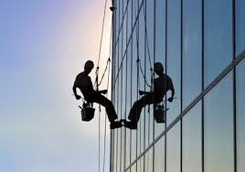
All employees must wear a full body harness when using a personal fall protection system for fall arrest. A full body harness must conform with the Canadian Standards Association, or other standards acceptable to WorkSafeBC. A full body harness and lanyard must be available for use any time there is a potential for a worker falling 10 feet or more.
Before using any fall arrest device, each person must be familiar with:
- inspection procedures;
  - correct method of wearing;
- how to install anchors;
- how to connect and use the harness in different situations.
When a fall arrest system is not practical, or will result in hazards that are greater than if the system were not used, the supervisor will ensure that:
- a safety monitor system with a control zone is used; or
- a risk assessment is completed to devise a procedure that would be compliant with WorkSafeBC Regulations.
Fall Arrest Equipment Inspection, Maintenance and Storage
Safety belts, harnesses, lanyards, lifelines, anchors, and other similar devices must be:
- inspected by a person before each use;
- kept free from substances and conditions that could contribute to their deterioration; and
- Maintained in good working order in accordance with manufacturers’ instructions.
A device or part that is defective in condition or function must be removed from service.
After any personal fall protection equipment has arrested the fall of an employee, it must:
- be removed from service, tagged; and
- not be returned to service until it has been inspected and re-certified for use by the manufacturer or its authorized agent, or by a structural engineer.
Fall protection equipment must be stored in a clean dry environment.
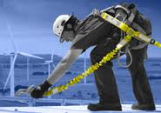
Fall Arrest Anchors
- All lifelines as well as lanyards used without lifelines, must be secured to anchors.
- An anchor plate with multiple eyes designed to support combinations of suspension lines, tie-back lines and lifelines must be designed by a structural engineer.
- A temporary anchor (such as a metal l-beam and lifeline combination) can be devised using other than engineered anchor points. A supervisor must be responsible for performing a risk assessment confirming its adequacy for load bearing before work commences. Temporary anchors must be part of the fall protection plan.
3.0 Elevating Equipment
Guardrails and toe boards for elevating work levels 3 meters (10 feet) or more above the ground or floor:
- Shall meet minimum regulatory requirements.
- Shall require a pre-use inspection prior to any usage of the scaffold.
Use extreme caution when using elevating equipment around power lines. A minimum distance of 10 feet should be maintained unless approved by the supervisor.
3.1 Scaffolding
Scaffolding must meet the requirements of Occupational Health and Safety Regulations. There are a number of scaffold types and the Regulations should be reviewed carefully for special requirements that apply to each type.
- The footing or anchorage for scaffolds shall be sound, rigid and capable of carrying the maximum intended load without settling or displacement. Unstable objects, such as barrels, boxes, loose brick, or concrete blocks shall not be used to support scaffolds or planks.
- Scaffolds and their components shall be capable of supporting at least four times the maximum intended load.
- Scaffolds shall be maintained in a safe condition and shall not be altered or moved horizontally while they are in use or occupied.
- Scaffolds must be secured to ensure stability during use.
- Platform wheels must be locked if used.
- Scaffold platforms must meet the requirements Damaged or weakened scaffolds shall not be used.
- A safe means must be provided to gain access to the working platform level through the use of a ladder, ramp, etc.
- Overhead protection must be provided for personnel on a scaffold exposed to overhead hazards.
- Guardrails, mid rails and toe boards must be installed on all open sides and ends of platforms more than 10 feet above the ground or floor. Mesh must be installed between the toe board and the guardrail along the entire opening, where persons are required to work or pass under the scaffolds.
- Employees shall not work on scaffolds during storms or high winds or when covered with ice or snow.
3.2 Elevating Work Platforms
Elevating work platforms must meet the following requirements.
Any personnel operating an Elevating Work Platform (e.g. JLG) must be trained and a holder of a valid certificate. The equipment must be inspected by the operator prior to use, using an inspection form designed for that particular piece of equipment. If deficiencies are found during the inspection, the equipment is to be tagged “Out Of Service” and the deficiency pointed out to the heavy duty mechanics immediately.
- Follow the safe work practices.
- Follow all warning instructions on the equipment.
- Pre use inspection on the equipment.
- Use all available protective and safety devices.
- Use caution when fuelling.
- Cleanup the work site.
- Check the work area.
- Plan your work.
- Check for overhead clearance to obstructions and power lines.
- Use the fall arrest harness at all times.
- Be knowledgeable of the safe load for the work platform.
- Travel at speeds safe for the area.
- Place hi-vis safety cones to warn others.
3.3 Work Platform (suspended by lift truck)
Manually Propelled ladder stands and scaffolds must meet the requirements of Regulation
A work platform must only be used in conditions where it is not feasible or practical to use another means - when all other reasonable options have been exhausted.
- The work platform used to lift personnel must be certified by a structural engineer. The lift truck forks must be inspected annually.
- The rated capacity of any lift truck must be clearly visible and sufficient to handle, without tipping, work platforms mounted the weight of the platform and its occupants and their contents (work tools).
- All work platforms must be secured by a device of adequate strength (chain) to the lift truck to prevent accidental dislodgment of the work platform from the lift truck.
- Inspection records must be kept for all inspections and repairs.
- A structural engineer must approve all alterations/repairs to a work platform.
- Approved hand signals must be used for communications by personnel in the work platform (radio communication is a suitable substitute for this).
- Only a designated worker may give signals, this will be determined prior to the start the task.
- No one may ride in a work platform mounted on a forklift while the lift truck is in motion.
- A pre-lift meeting must be held for all personnel that are involved in the lift prior to the actual lift commencing.
- The area surrounding the work platform must be identified by the use of hi-vis safety cones.
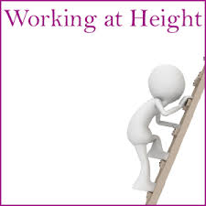
4.0 Ladders
Ladders must meet the requirements of regulation.
Proper use of ladders is essential in preventing accidents. Even a good ladder can be a serious safety hazard when used by workers incorrectly. (See Appendix for General Ladder Safety).
- Ladders shall be inspected before each use and those which have developed defects shall be withdrawn from service for repair or destruction and tagged or marked as “Dangerous, Do Not Use”.
- Use both hands when climbing or descending ladders - do not carry heavy or bulky objects that make climbing unsafe.
- The worker shall always face the ladder when climbing up or down.
- Metal ladders shall never be used near electrical equipment.
- Only one person should be on a ladder at a time and no work is to be done from the top two rungs of single or extension ladders, or from the top two steps of step ladders.
- Fall protection is required when the ladder is positioned near an edge or floor opening that significantly increases the fall hazard.
4.1 Portable Ladders
The various types of portable ladders include:
- Stepladder – A self-supporting portable ladder, non-adjustable in length, having flat steps and hinged back.
- Single Ladder – A non self-supporting portable ladder, nonadjustable in length, consisting of but one section. Its size is designed by overall length of the side rail.
- Extension Ladder – A non self-supporting portable ladder adjustable in length.
Portable Ladder Safety Precautions:
- Ladders shall be placed with a secure footing, and they shall be tied at the top, or held in position when the ladder is being used to facilitate work.
- Ladders used to gain access to a roof or other area shall extend at least 3 feet above the point or support.
- The foot of a ladder shall be used at such a pitch that the horizontal distance from the top support to the foot of the ladder is one-quarter of the working length of the ladder (the length along the ladder between the foot and the support).
- Ladders shall never be used in the horizontal position as scaffolds or work platforms.
- The top of a regular stepladder shall not be used as a step.
- It is permissible to work off a ladder for a short period of time (less than 15 minutes) without the need to hook on if 3 point contact is maintained – i.e. Replacing a light bulb where your 2 feet and one hand (3 point contact) maintained.
4.2 Fixed Ladders
A fixed ladder is a ladder permanently attached to a structure, building or equipment. Fixed ladders, with a length of more than 20 feet to a maximum unbroken length of 30 feet shall be equipped with cages fastened to the side rails of the fixed ladder or to the structure to encircle the climbing space.
A fixed ladder less than 20’ if used only for access does not need to be caged.

Referenced/Related Documents
Appendices/Attachments:
Appendix #1 – Sample Written Fall Protection Plan Sample
Appendix #2 – General Ladder Safety
Appendix #3 – Definitions
Appendix #1
Sample Fall Protection Plan
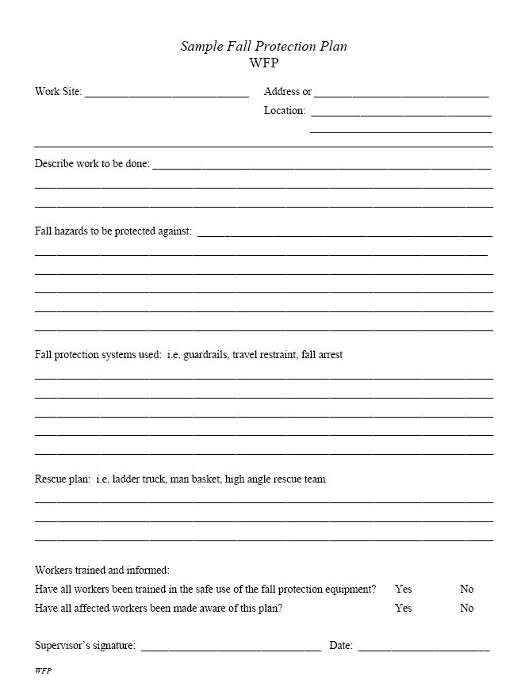

Appendix #2
4.1 General Ladder Safety
Inspect ladders before use — unsafe ladders must be removed from service and tagged with a defective equipment tag.

Metal ladders, or wire-reinforced wooden ladders, shall not be used in proximity to energized electrical equipment.
• Use all ladders in accordance with manufacturers’ instructions.

Wooden ladders should not be painted — paint can conduct electricity. Paint can also hide cracks or other damage.

The safe working angle of a ladder is obtained when the distance from the foot of the ladder to the base of the vertical support is approximately one-fourth of the ladder height to the top support — ensures extension and overlap meet WCB requirements.

Ladders must be tied, blocked or otherwise secured to prevent them from slipping sideways.

Appendix #3
Definitions
"anchor" means a secure point of attachment for a lifeline or lanyard;
"fall arrest system" means a system that will stop a worker's fall before the worker hits the surface below;
"fall protection system" means
- a fall restraint system,
- a fall arrest system, or
- work procedures that are acceptable to the Board and minimize the risk of injury to a worker from a fall;
"fall restraint system" means a system to prevent a worker from falling from a work position, or from travelling to an unguarded edge from which the worker could fall;
"full body harness" means a body support device consisting of connected straps designed to distribute the force resulting from a fall over at least the thigh, shoulders and pelvis, with provision for attaching a lanyard, lifeline or other components;
"horizontal lifeline system" means a system composed of a synthetic or wire rope, installed horizontally between 2 anchors, to which a worker attaches a personal fall protection system;
"lanyard" means a flexible line of webbing, or synthetic or wire rope, that is used to secure a safety belt or full body harness to a lifeline or anchor;
"lifeline" means a synthetic or wire rope, rigged from one or more anchors, to which a worker's lanyard or other part of a personal fall protection system is attached;
"personal fall protection system" means a worker’s fall restraint system or fall arrest system composed of
- a safety belt or full body harness, and
- a lanyard, lifeline and any other connecting equipment individual to the worker that is used to secure the worker to an individual point of anchorage or to a horizontal lifeline system;
"safety belt" means a body support device consisting of a strap with a means for securing it about the waist and attaching it to other components;
Definitions
In this Part:
"boom-supported" means supported by an elevating device that telescopes, articulates, rotates or extends relative to the machine base or vehicle, so that the platform can be positioned completely beyond the base;
"boatswain's chair", also known as a bosun's chair, means a seat attached to a suspended rope designed to accommodate one person in a sitting position;
"elevating work platform" means a movable work platform that self-elevates to overhead work locations;
"movable work platform" means a work platform that can be re-positioned during the course of the work;
"permanent powered platform" means a movable work platform that
- is raised or lowered by other than manual means, and
- is permanently installed on or attached to a building or structure;
"portable powered platform" means a movable work platform that
- is raised or lowered by other than manual means, and
- is not permanently installed on or attached to a building or structure;
"scaffold" means any temporary elevated work platform and its supporting structure used for supporting workers, materials or equipment;
"self-propelled" means the capability of an elevating work platform to travel under power with the primary controls on the work platform;
"swing stage" means a work platform that is raised and lowered by manual or powered hoisting equipment, supported by 2 or more suspension lines;
"work platform" means an elevated or suspended temporary work surface used for supporting workers and includes a scaffold and boatswain's chair.

Dos and don’ts of working at height

Do….
- as much work as possible from the ground
- ensure workers can get safely to and from where they work at height
- ensure equipment is suitable, stable and strong enough for the job, maintained and checked regularly
- take precautions when working on or near fragile surfaces
- provide protection from falling objects
- consider emergency evacuation and rescue procedures

Don’t…
- overload ladders – consider the equipment or materials workers are carrying before working at height. Check the pictogram or label on the ladder for information
- overreach on ladders or stepladders
- rest a ladder against weak upper surfaces, eg glazing or plastic gutters
- use ladders or stepladders for strenuous or heavy tasks, only use them for light work of short duration (a maximum of 30 minutes at a time)
- let anyone who is not competent (who doesn’t have the skills, knowledge and experience to do the job) work at height

